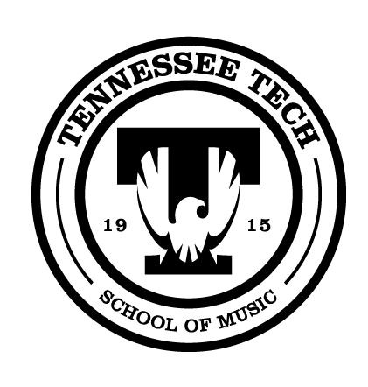
Tennessee Tech University
School of Music
1050 N. Dixie Ave.
Campus Box 5045
Cookeville, TN 38505-0001

A REGISTRATION FEE 0F $15 CAN BE
PAID AT THE DOOR OR IN ADVANCE
AT TNTECHFLUTE.COM

All students auditioning for a Tennessee Tech Music Scholarship
On February 7 receive FREE admission to Flute Day.

8:30 – 9:30 a.m. : Registration & Visit Exhibits
9:30 – 10:00 a.m. : Group Warmup lee by Brook Ferguson
10:00 – 11:00 a.m. : High School Masterclass with Brook Ferguson
11:00 – 11:45 a.m. : Flute Repair and Maintenance Class with Karen Barr
11:45 – 12:45 p.m. : Lunch & Visit Exhibits
12:45 – 1:30 p.m. : Brook Ferguson in Recital
1:30 – 2:15 p.m. : Flute Choir Reading Session with Dr. Mary Matthews
2:15 – 2:45 p.m. : Workshop with Dr. Matthews
2:45 – 4:00 p.m. : Tennessee Tech Students in Masterclass with Brook Ferguson
4:00 – 4:30 p.m. : Q & A with Guest Artists

For additional information, contact:
Dr. Mary Matthews, Tennessee Tech Flute Professor
Email: mmatthews@tntech.edu
Office Phone: 931-372-6083

