Accounting Manual
Accounting Policies can be found at https://tntech.policytech.com/?auto=false. Specifically, section 500 relates to Accounting and Purchasing.
A closing memo is issued each fiscal year to outline accounting procedures. You may find the closing memo for 6/30/16 at https://www.tntech.edu/planning-and-finance/business/financialservices/
TTU’s Office of Business and Fiscal Affairs has several procedures broken down into separate manuals to facilitate training and detailed procedures. Monthly trainings are conducted by the Director of Accounting and/or the Department of Purchasing and Contracts on the following subjects:
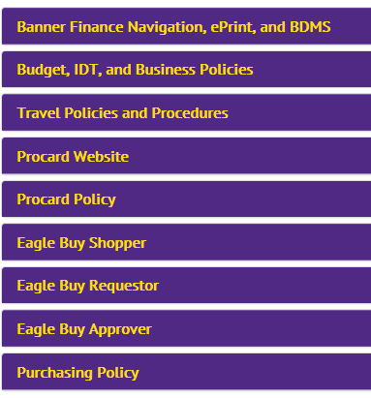
Accounting Manuals pertaining to the above can be found at https://www.tntech.edu/planning-and-finance/business/training
Travel https://www.tntech.edu/assets/userfiles/resourcefiles/17886/1475176130_Travel%20Policies%20and%20Procedures%20Manual.pdf
Expense Code Listing https://www.tntech.edu/assets/userfiles/resourcefiles/17886/1475087083_Account%20Code%20Listing.pdf
Interdepartmental Transfers https://www.tntech.edu/assets/userfiles/resourcefiles/17886/1475176122_Interdepartmental%20Transfers%20Manual.pdf

Purchases made with Procard https://www.tntech.edu/assets/userfiles/resourcefiles/10121/1472238125_Procard%20User%20Guide%20rev%208-26-16.pdf

In addition, TTU follows the Tennessee College System of Tennessee (TBR) policies and guidelines on the following:
Fixed Assets and Sensitive Minor Equipment – TBR B:110 https://policies.tbr.edu/guidelines/fixed-assets-and-sensitive-minor-equipment
Disposal of Surplus Personal Property – TBR 4:02:20:00 https://policies.tbr.edu/policies/disposal-surplus-personal-property
Preventing and Reporting Fraud, Waste or Abuse – TBR 4:01:05:50 https://policies.tbr.edu/policies/preventing-and-reporting-fraud-waste-or-abuse

