Office of Grant Accounting
Tennessee Tech University
Desk Procedure

DEFINITION AND PURPOSE OF GRANT CODE AND FOAPAL
TTU’s Accounting Hierarchy
In compliance with 2 CFR 200.302, each grant is assigned a unique Grant Code and FOAPAL within the Banner Finance System. The FOAPAL is an acronym indicating Fund Code, Organization Code, Account Code, Program Code, Activity Code, and Location Code. An Index Number is established that correlates to the FOAPAL.
Index – a unique 6-digit identifier assigned to each separate grant – 53xxxx
Fund – a unique identifier to separate restricted funds from the University general fund on the balance sheet. See table below:
Restricted Funds
20xxxx | Endowments
21xxxx | Restricted Appropriations
22xxxx | Federal Funds
 | 220xxx | Department of Education
 | 221xxx | Not used
 | 222xxx | National Science Foundation
 | 223xxx | Department of Energy
 | 224xxx | Department of Agriculture
 | 225xxx | National Aeronautics and Space Administration
 | 226xxx | Department of Defense
 | 227xxx | Department of Interior
 | 228xxx | All other federal funds
 | 229xxx | ARRA
23xxxx | State Funds
24xxxx | Local Funds
25xxxx | Private Funds / Corporate Funds
26xxxx | Gifts

Organization – A restricted 6-digit number that identifies the Principal Investigator’s organization for the grant. All organization codes used for grants will end with the #3 which indicates restricted funds. See below for an example of restricted organization codes:
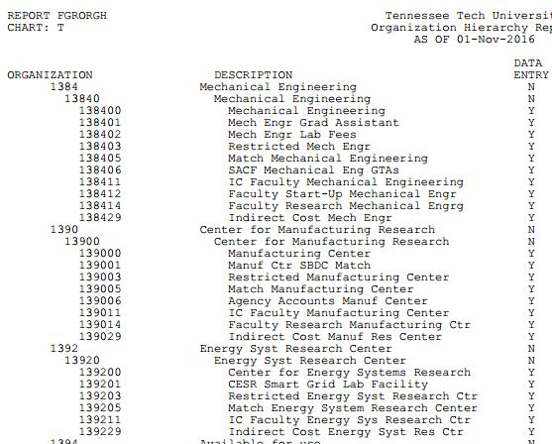

Program Codes – A 3-digit code that designates the functional category of the grant and groups expense according to the purpose of the grant. See below for TTU program codes:
Program Code | Description
200 | Instruction
250 | Research
300 | Public Service
350 | Academic Support
400 | Student Services
450 | Instructional Support
500 | Physical Plant
500 | Capital Projects
550 | Scholarships
710 | Auxiliary

Grant Code - A unique grant code that ties to the proposal number assigned by the Office of Research. The grant code is a 9-digit number that begins with the fiscal year of the proposal no. (see Grant Activation Form); has “G” as the 5th character and the actual proposal no. as the last 4 digits. For example. A grant with the Proposal No. of “86 (15-16)” would be assigned the grant code of “1516G0086.”

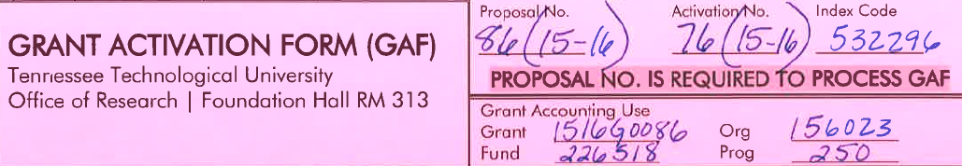

The FOAPAL string is how financial information from one funding source is segregated from information from another funding support. Specifically, for Award No. DUE-1439895, the unique FOAPAL is 531284 – 222084 – 131513 – 250
Index – 531284 Screen Shot from Report FGRACCI shows the description, fund, organization and program associated with the Index:
Fund – 222084 (the beginning numbers of 222 show that the funds are Federal funds via the National Science Foundation). Below are screen shots from Report FGRFNDH:
Organization – 131513 – PI Jeffrey Boles is a faculty member in the Chemistry Department and the restricted organization code for his department is used. Below is a screen shot of the Chemistry Department org codes from Report FGRORGH:
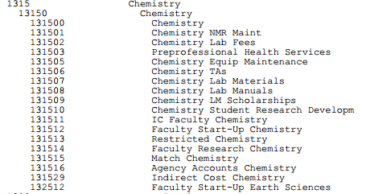
Program - 250 – The purpose of the grant is research: Report FGRPRGH

Additionally, the grant code created from the Office of Research’s proposal number is tied to the NSF Contract Code. See below for screen shot of FRAGRNT screen from Banner Finance:
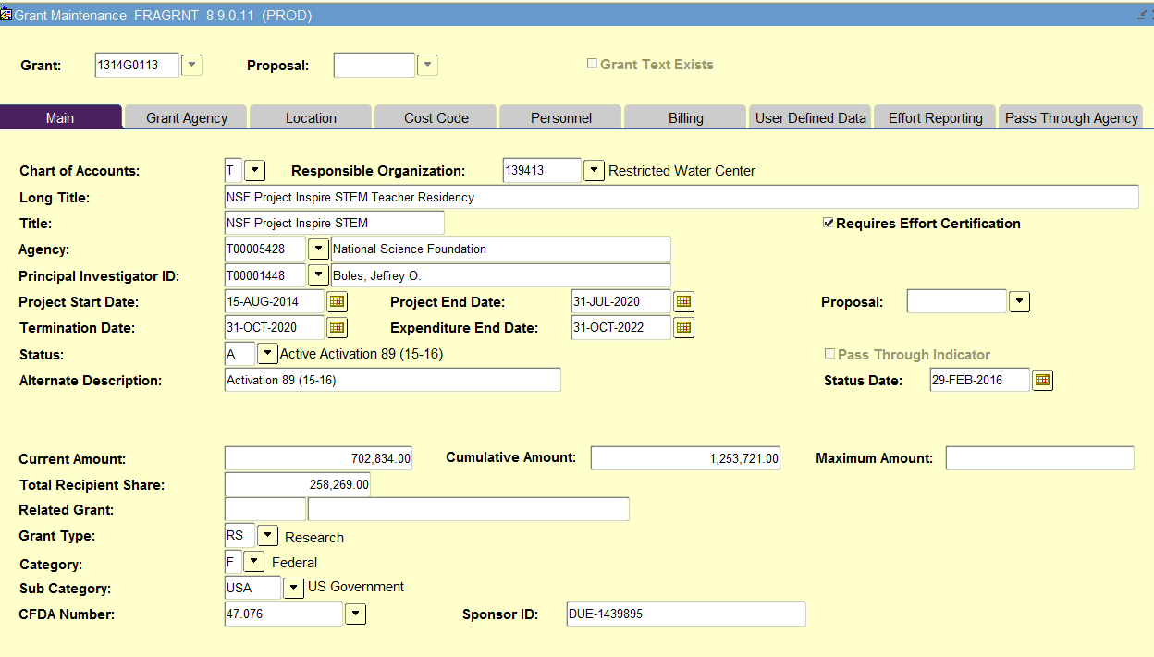

Sources/References:
FGRORGH – Organization Hierarchy Report
FGRPRGH – Program Hierarchy Report
FGRFNDH – Fund Hierarchy Report
FGRACCI – Account Index Report

