Office of Grant Accounting
Tennessee Tech University
Desk Procedure

RECORD RETENTION

In compliance with The State of Tennessee Records Management Division, all grant files will be maintained and retained for five years after the final expenditure report has been submitted. See RDA SW21 for the entirety of the disposition of grant files. http://tnsos.net/rmd/rda/detail_rda.php?rda_id=1932
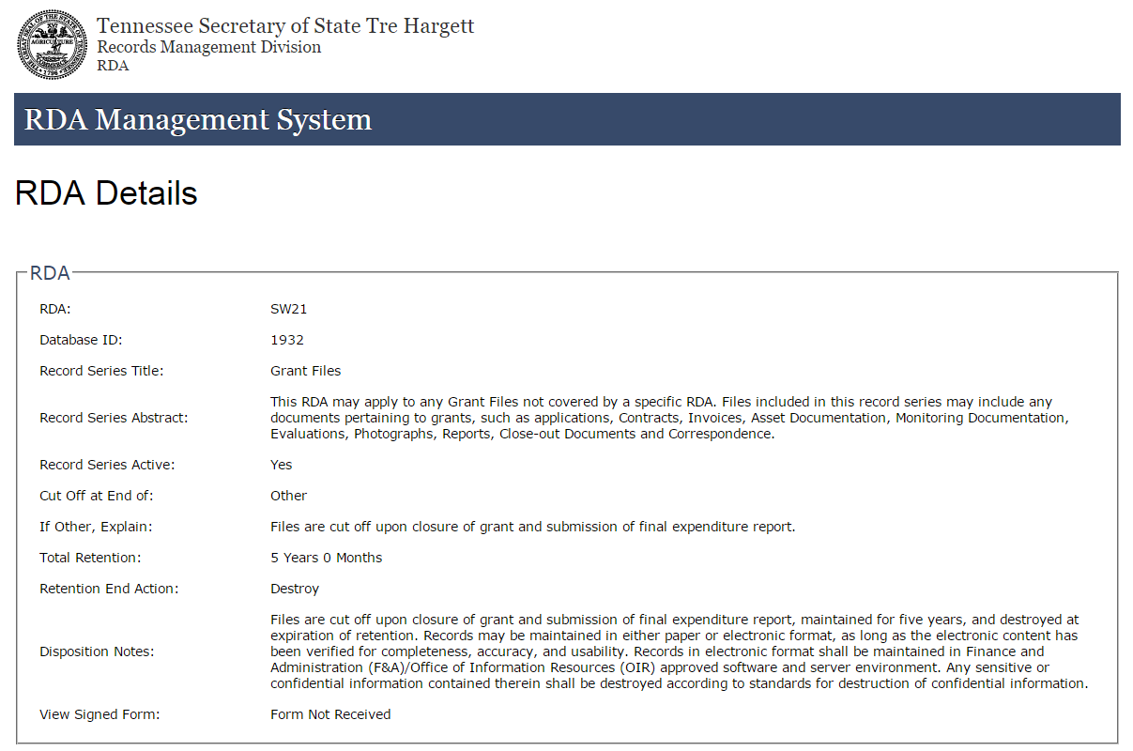

The Office of Grant Accounting maintains a retention log by Fiscal Year that contains scanned files of grants closed during that particular fiscal year.
Per 2 CFR 200.333 all records related to a Federal award must be retained for a period of three years from the date of submission of the final expenditure report; however the Office of Grant Accounting will abide by RDA SW21.
https://policies.tbr.edu/guidelines/records-retention-and-disposal-records

