Here are how things worked out, according to ChatGPT (Proposal 3 is the winner!):

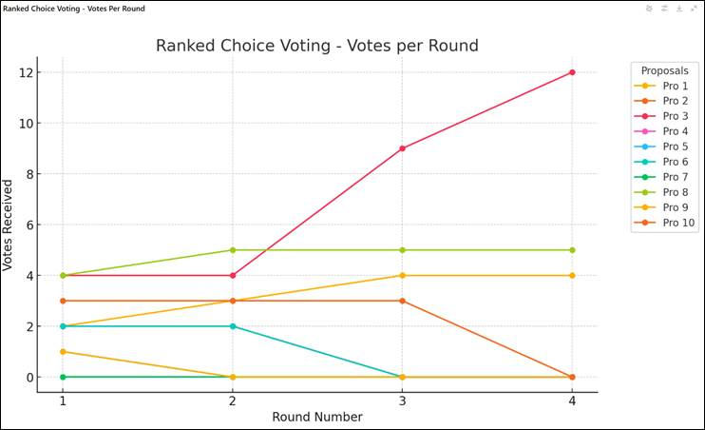

Round 1: Initial Vote Count
Each voter’s first-choice votes are counted.
- Proposal 7: 0 votes
- Proposal 3 & Proposal 8: 4 votes each
- Proposal 10: 3 votes
- Proposal 2 & Proposal 6: 2 votes each
- Proposal 4 & Proposal 1: 2 votes each
- Proposal 9 & Proposal 5: 1 vote each (Lowest)
🔹 Proposal 7, 9 & Proposal 5 are eliminated (since they received the fewest votes).
🔹 Their votes are redistributed to each voter's next choice.

Round 2: Redistribution After Eliminations
The eliminated proposals' votes go to the next-ranked choices on those ballots.
- Proposal 8 gains 1 extra vote (from P3, the person who voted for #9 as their first choice) (total: 5)
- Proposal 7 was already eliminated.
- Proposal 3 stays the same (total: 4)
- Proposal 10 stays the same (total: 3)
- Proposal 2 stays the same (total: 2)
- Proposal 6 stays the same (total: 2)
- Proposal 4 stays the same (total: 2)
- Proposal 1 gains 1 extra vote (total: 3)
🔹 Proposal 9 & Proposal 5 were already eliminated.
🔹 Now, Proposal 2 & Proposal 6 are eliminated (since they still have the fewest votes).
🔹 Their votes are redistributed.

Round 3: More Redistributed Votes
Now that Proposal 2 & Proposal 6 have been eliminated, their votes go to the next available choices on voters' ballots.
- Proposal 3 jumps up to 9 votes
- Proposal 8 stays at 5 votes
- Proposal 10 stays at 3 votes
- Proposal 4 stays at 2 votes
- Proposal 1 increases to 4 votes
🔹 Proposal 4 is eliminated (fewest votes).
🔹 Votes for Proposal 4 are redistributed.

Round 4: Another Proposal is Eliminated
With Proposal 4 eliminated, those votes go to remaining choices.
- Proposal 3 reaches 12 votes
- Proposal 8 stays at 5 votes
- Proposal 10 is eliminated (0 votes left)
- Proposal 1 remains with 4 votes
🔹 Proposal 10 is eliminated.
🔹 No need for another round—Proposal 3 has the majority (>50%) and is declared the winner! 🎉

Final Winner:
🏆 Proposal 3 wins with 12 votes!
🔹 Proposal 8 was the second most popular option with 5 votes.
🔹 Proposal 1 held on until the end but only got 4 votes.

Key Takeaways:
- Proposal 3 started with only 4 votes but steadily gained support as other proposals were eliminated.
- Proposals 9 and 5 were eliminated early due to lack of support.
- Once Proposal 3 reached 12 votes, it crossed the 50% threshold and won outright.
- No single proposal had a strong lead initially, but the process ensured a winner with majority support.

Checked by hand and….
I got 13 votes for #3 in the last round and 8 votes for #8 in the last round, so I got the same winner as ChatGPT. In the round before that, I got 8 votes for #3, 6 votes for #6, and 7 votes for #8. I think the difference is what happens when proposals are tied in a given round. I’ll dig into the tiebreaker rules to see if I can reproduce the ChatGPT results.

