Gen Ed Survey 2 Voting Summary

NOTE: Desmos, the survey system used in this survey, lists all respondents as “students” and anonymizes them by replacing their names with famous mathematicians. Respondents to this survey were exclusively members of the Gen Ed Implementation Committee.

Table of Contents
Quantitative Reasoning & Analysis 2
QRA Choice Rationale 3
3 hours 3
Min: 3 hours 4
QRA Choice Ranking 5
Humanities and Cultural Expression 6
HCE Choice Rationale 7
Min: 6 hours 7
6 to 9 hours 7
HCE Choice Ranking 9
Literature Requirement 10
Literature Req. Rationale 11
Yes 11
No 12
Historical Foundations 14
HiFo Rationale 14
6 hours 14
Min: 3 hours 15
3 to 6 hours 16
HiFo Ranking 17
Social and Behavioral Sciences 17
SBS Rationale 18
6 hours 18
Min: 6 hours 18
SBS Ranking 19
Communication 20
Comm Rationale 20
Min: 6 hours (min: 3 comps; min 3 oral) 20
6 to 9 hours (min: 3 comps; min 3 oral) 21
9 hours (6 comps; 3 oral) 22
9 hours (min: 3 comps; min 3 oral) 22
Comm Ranking 23
Scientific Reasoning 24
SR Rationale 25
8 hours 25
Min: 4 hours 25
4 to 8 hours 26
SR Ranking 26
Financial & Digital Name Preference 27
F&D Rationale 27
Financial & Digital Literacy 27
Financial & Digital Core 28
Other 28
Financial & Digital Preference 29
F&D Preference Rationale 30
Leave Category open for individual program/students to choose from among financial and digital course offerings. 30
Require all students in all majors to take at least 1 credit of financial and 1 credit of digital 30
Financial & Digital Category 31
F&D Rationale 31
3 hours 31
Min: 3 hours 32
3 to 4 hours 32
3 to 6 hours 32
F&D Ranking 33
Voting 34
Voting Rationale 35
Voice Vote 35
Show of Hands 35
Ballot voting 35
Ranked Choice Voting 35
Each Subcommittee Rank their top Two Choices 35
Proposals 36
Proposals Rationale 37
Proposal 2 37
Proposal 3 37
Proposal 9 38
Proposal 11 38
Proposal Ranking 39
Final Thoughts 40

Quantitative Reasoning & Analysis

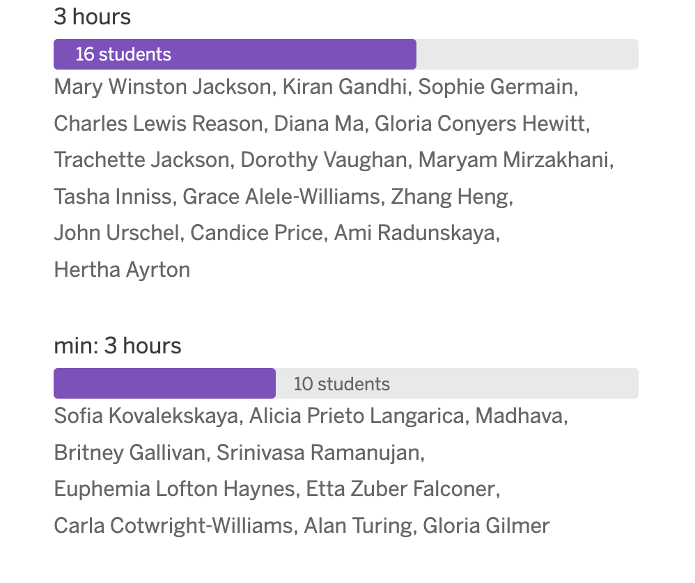

QRA Choice Rationale

3 hours
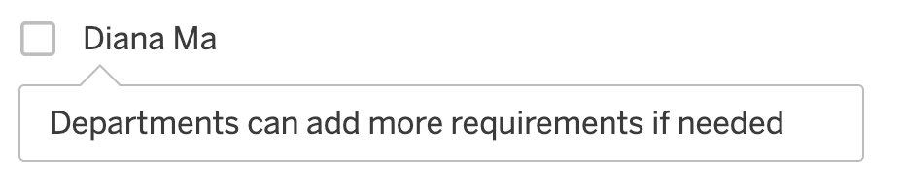
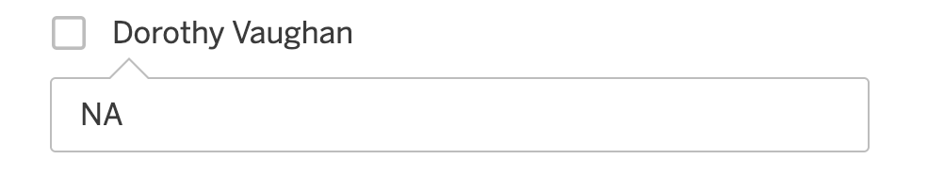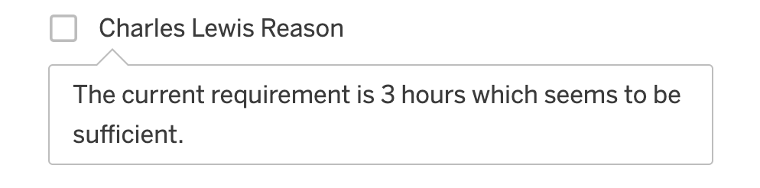
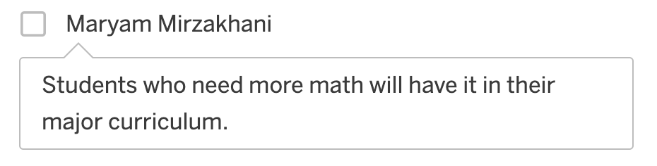

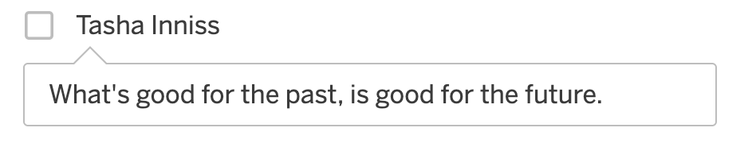

Min: 3 hours
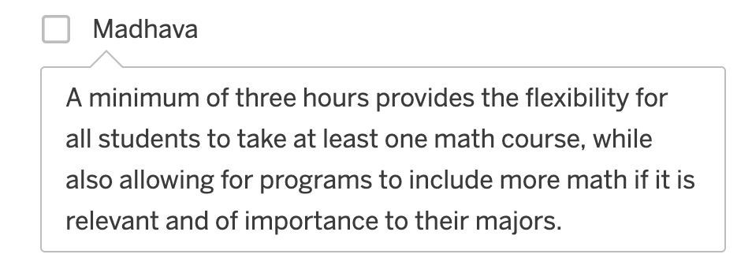
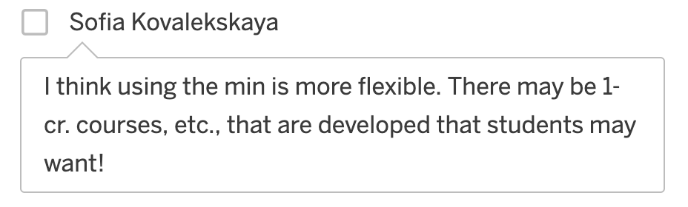
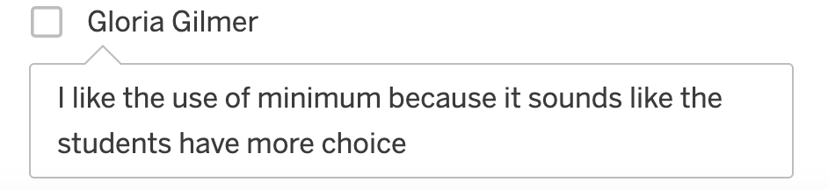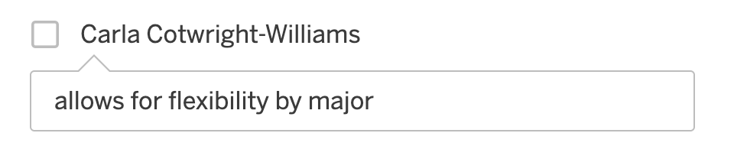
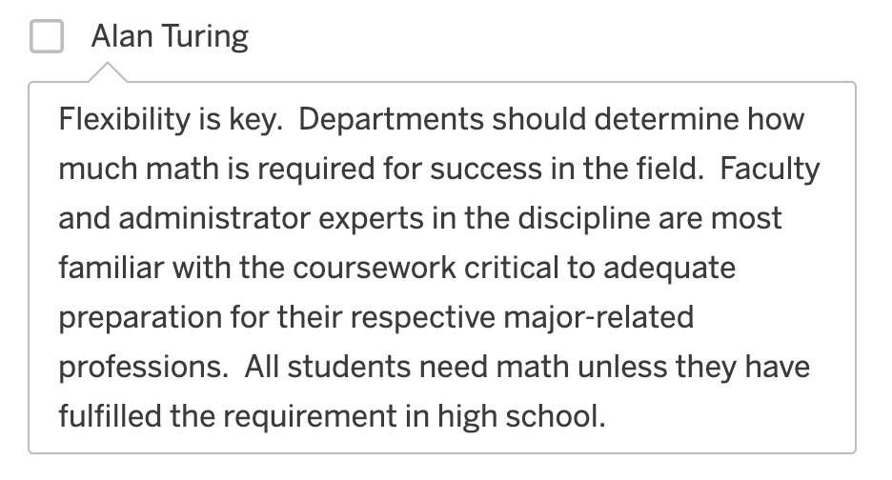

Humanities and Cultural Expression
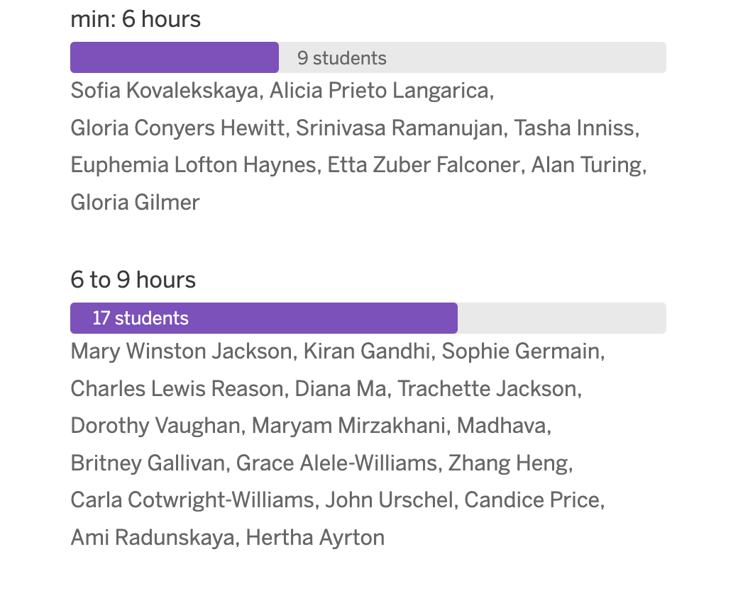

HCE Choice Rationale

Min: 6 hours
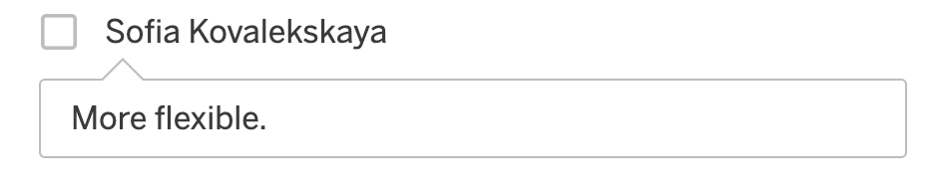
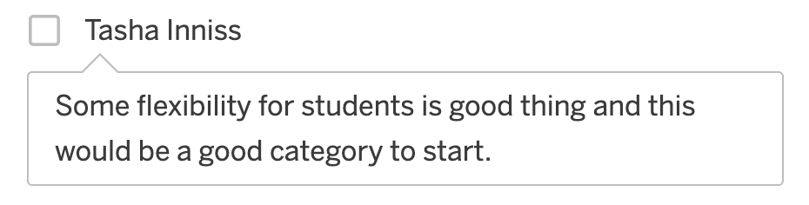
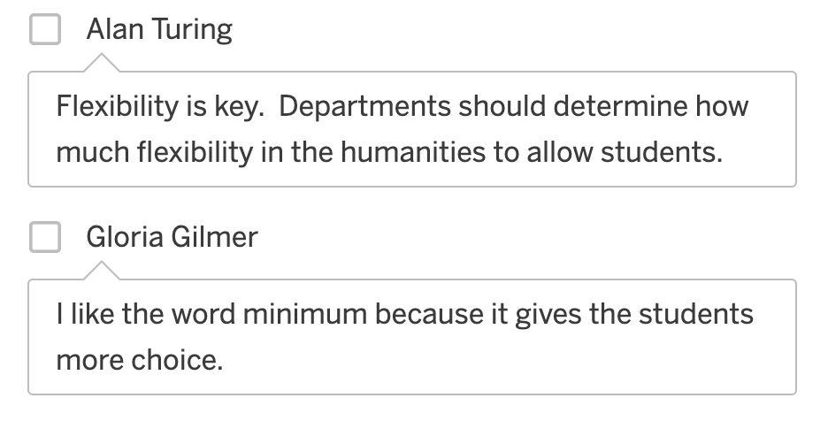

6 to 9 hours
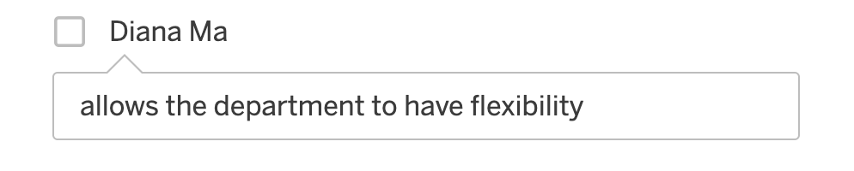
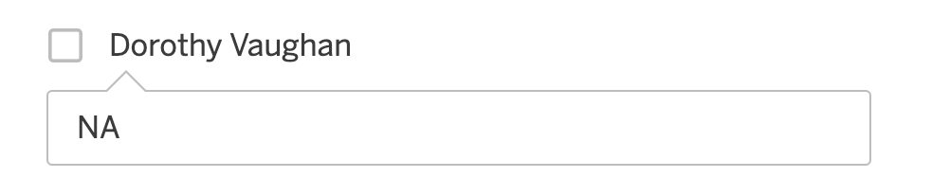
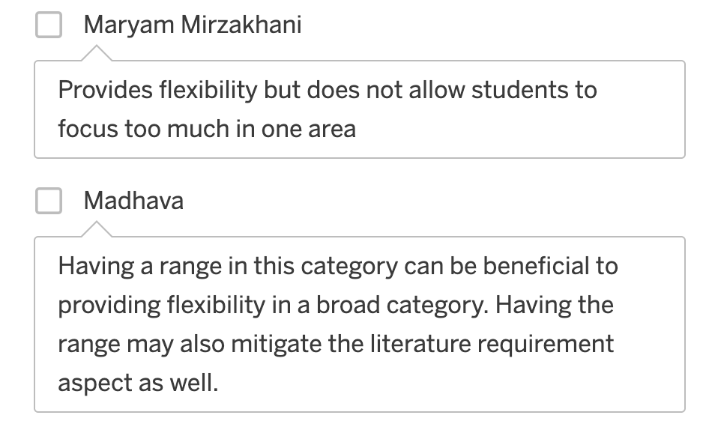
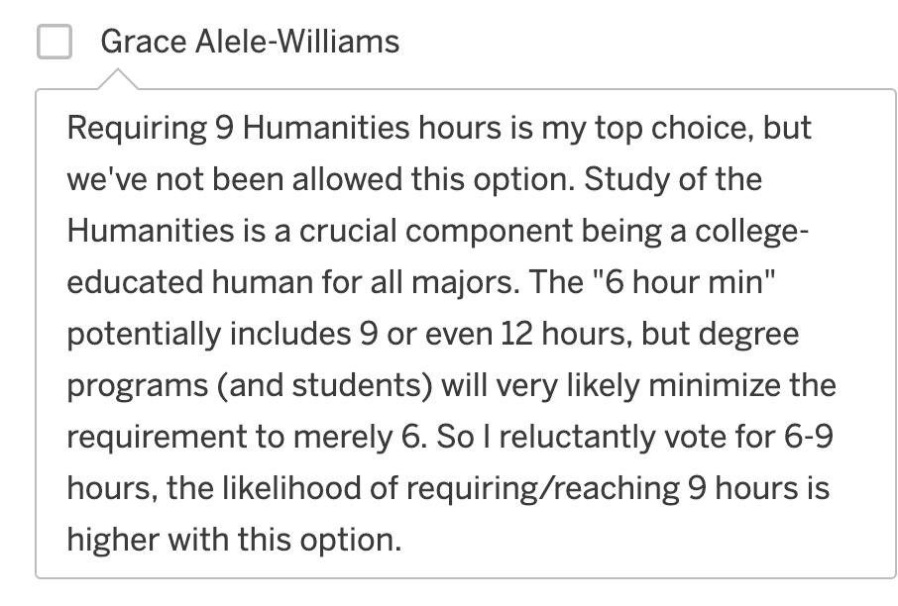
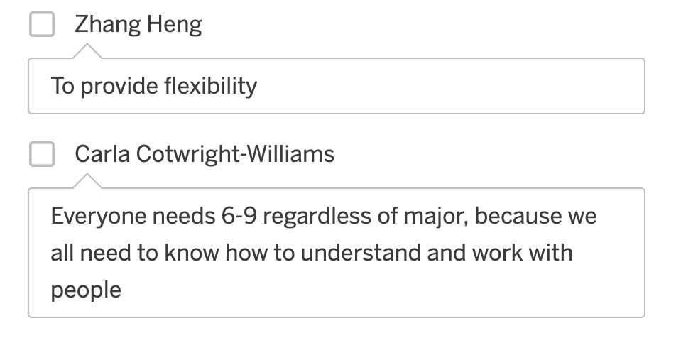
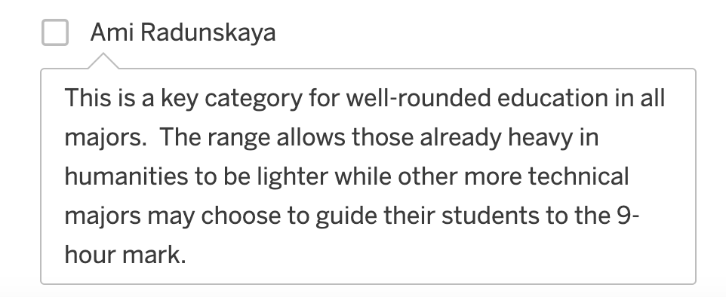

Literature Requirement
Do you think we should require all students in all majors to take a literature course within the Humanities & Cultural Expression Category?
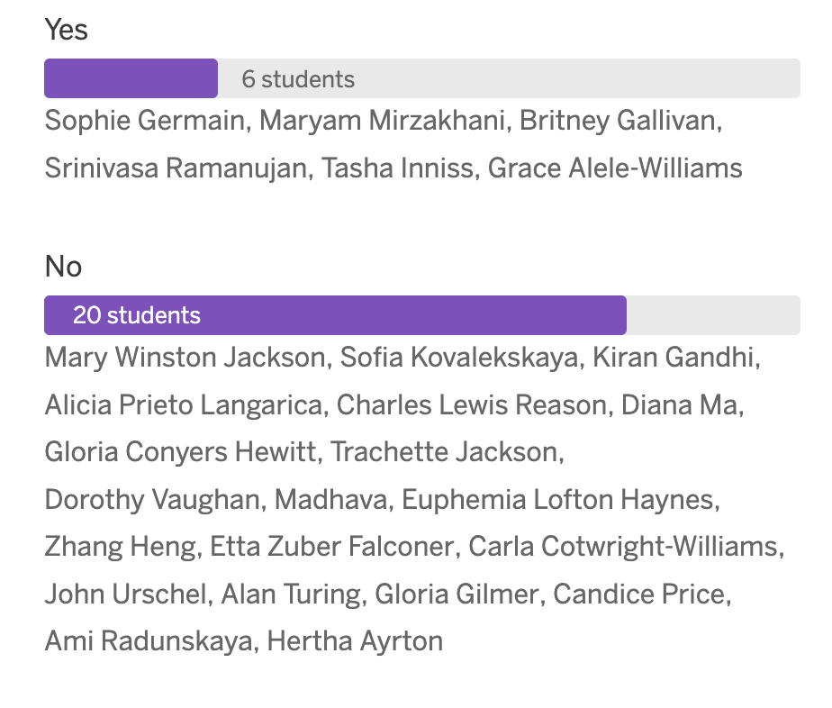

Literature Req. Rationale

Yes
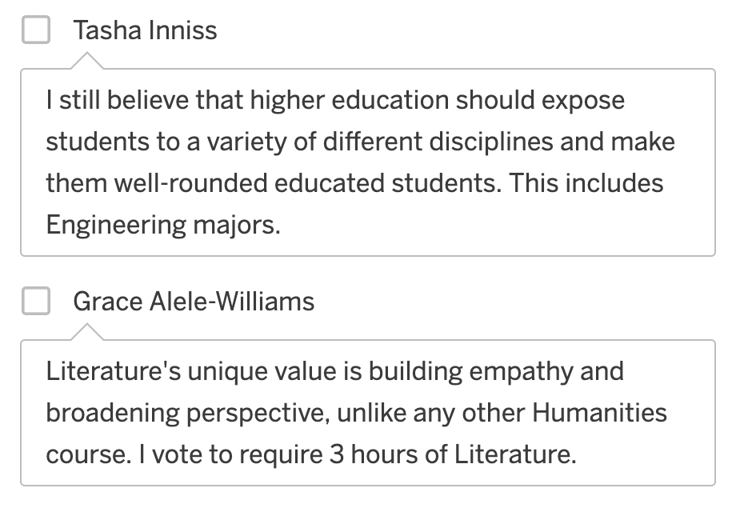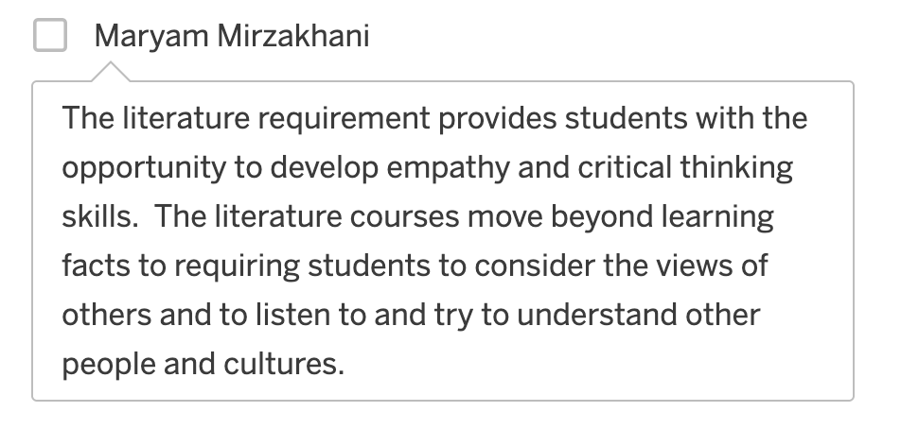

No
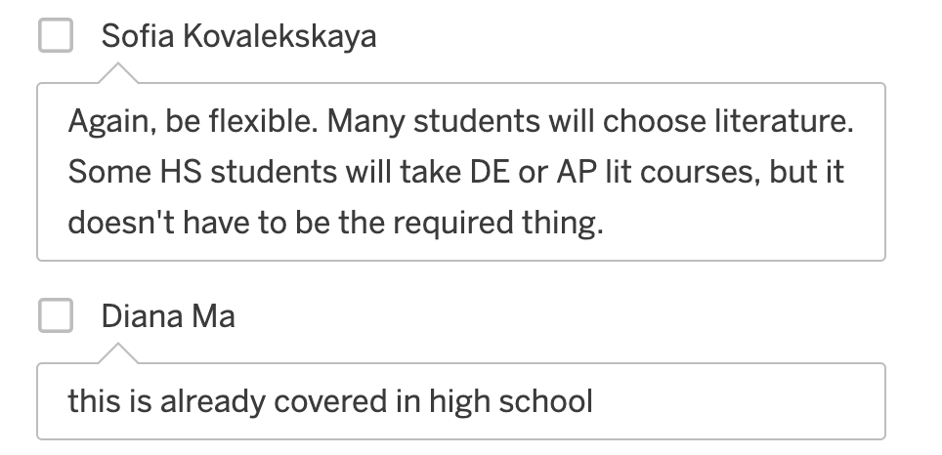
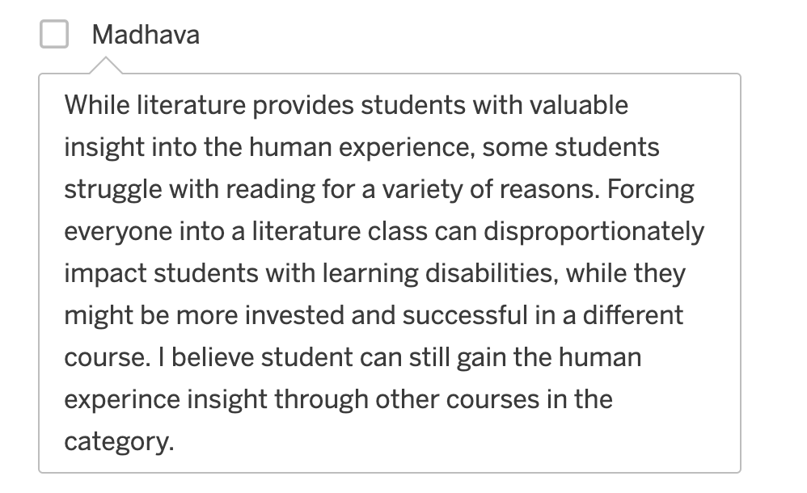
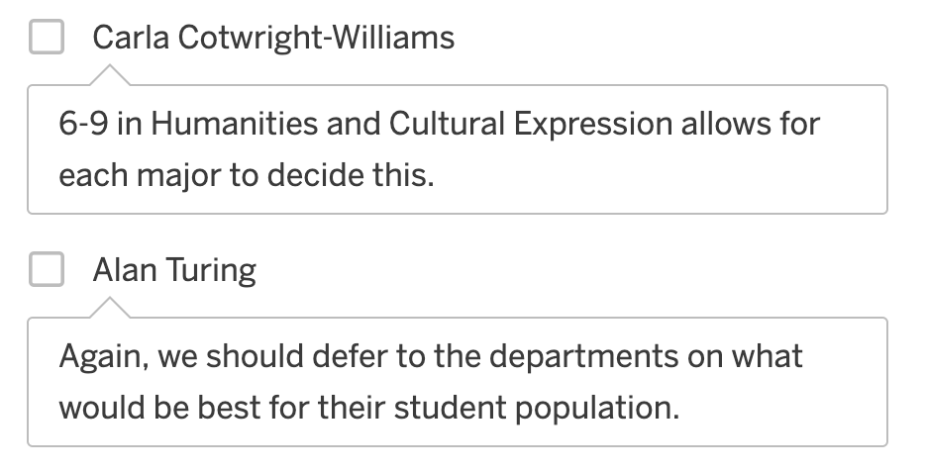
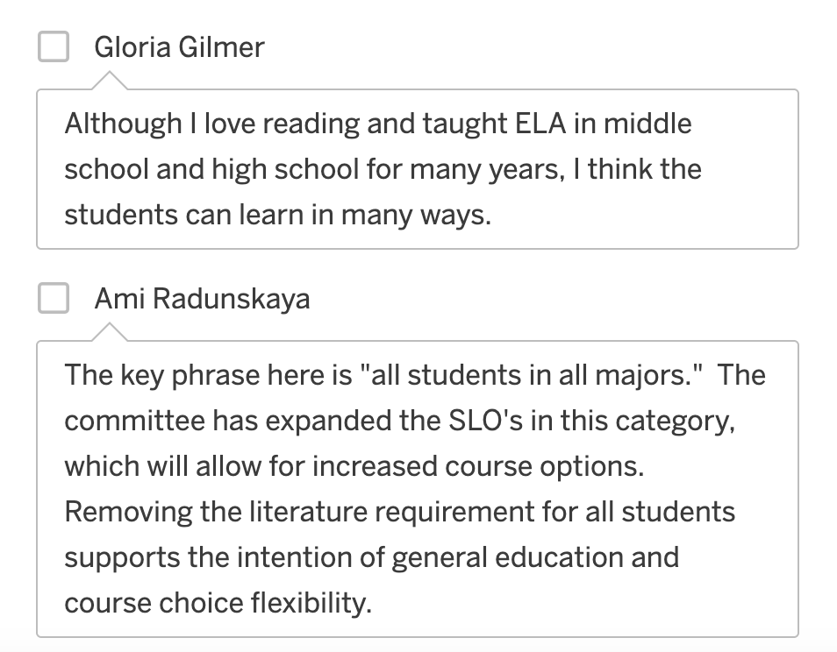

Historical Foundations

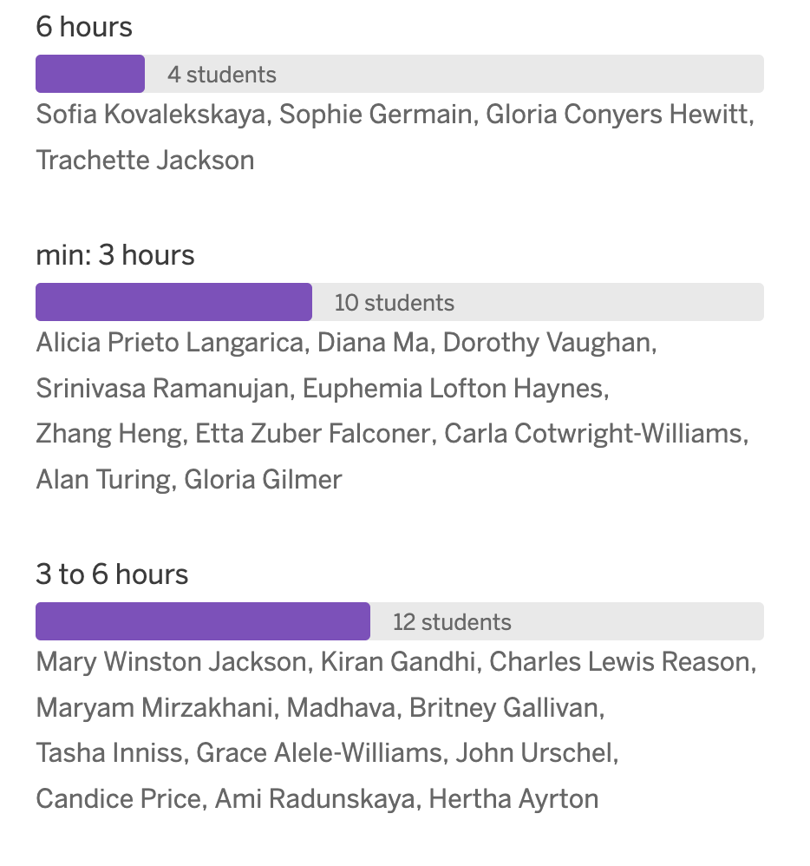

HiFo Rationale

6 hours
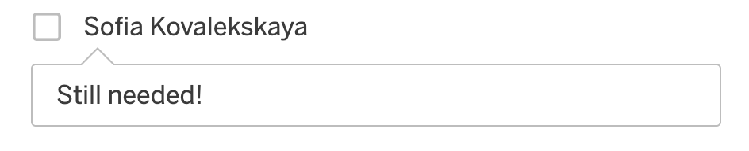

Min: 3 hours
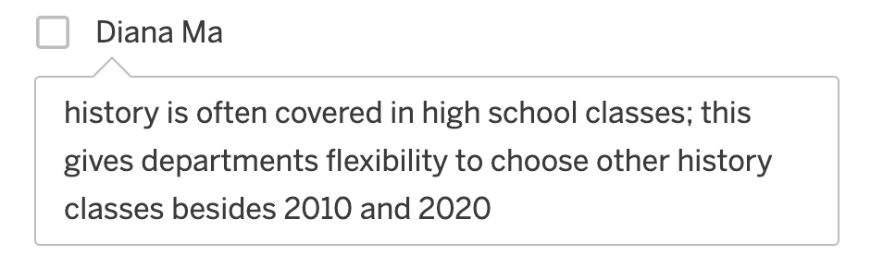
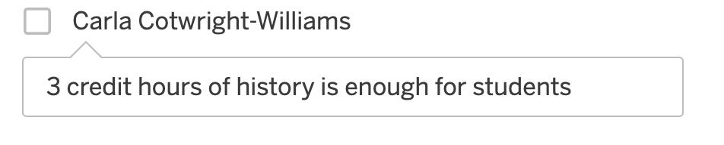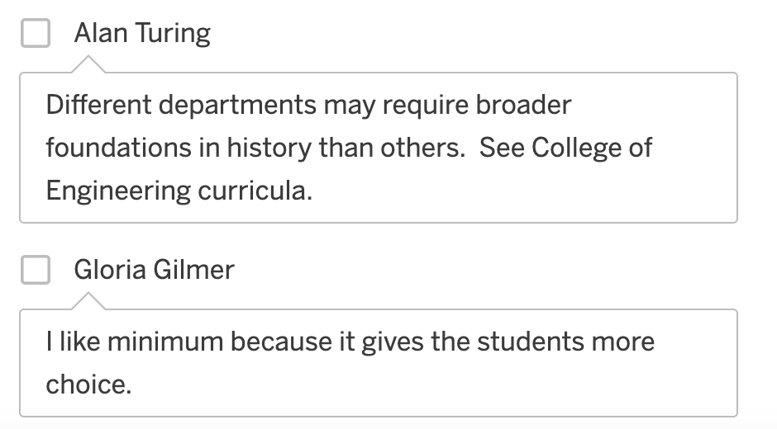

3 to 6 hours
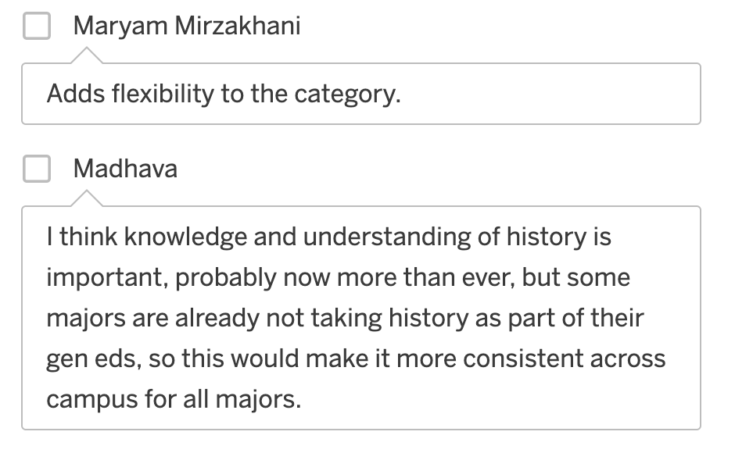
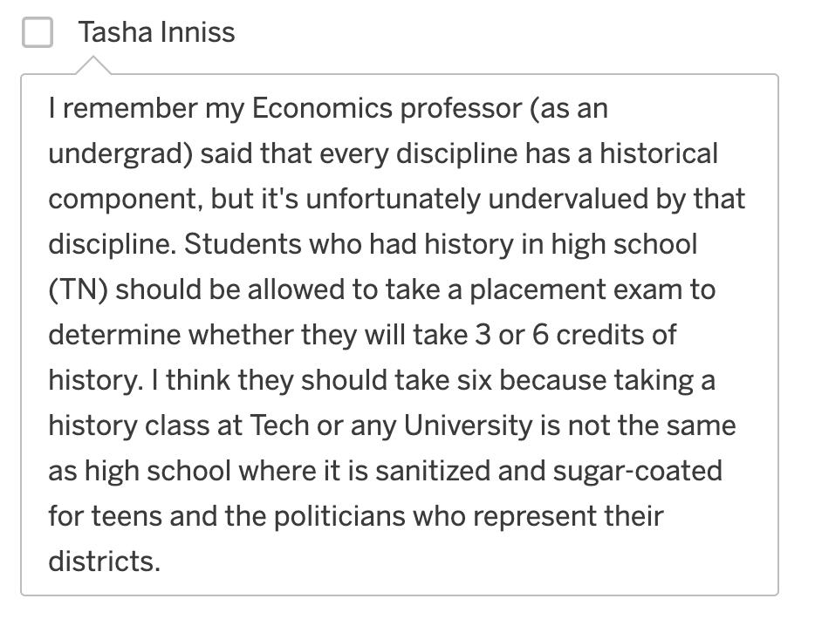

HiFo Ranking

Social and Behavioral Sciences

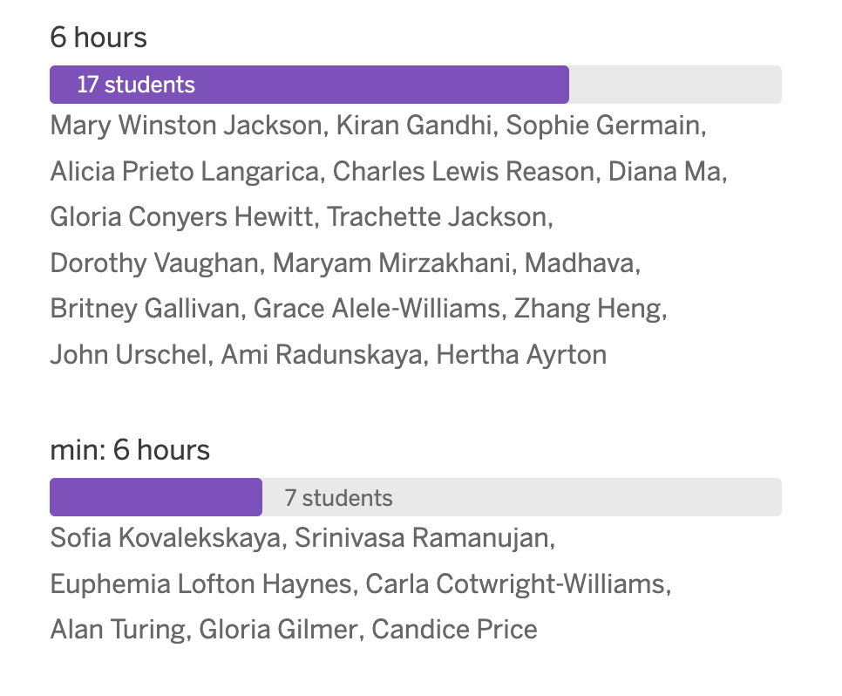

SBS Rationale

6 hours
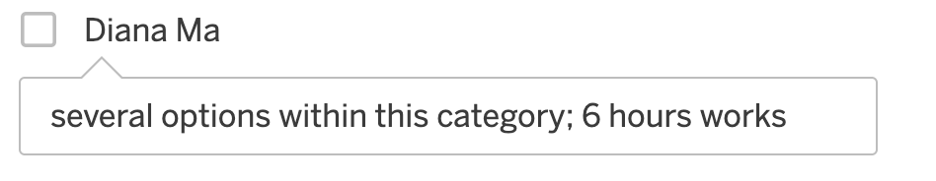
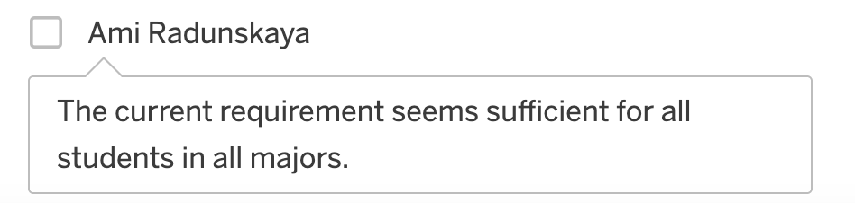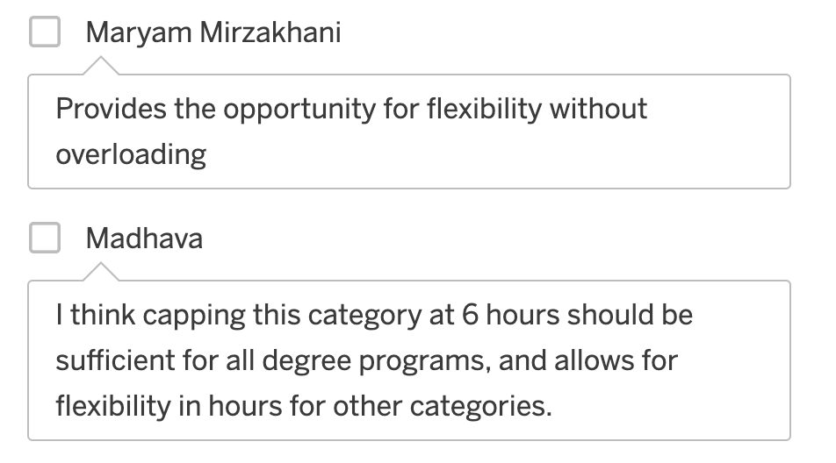

Min: 6 hours
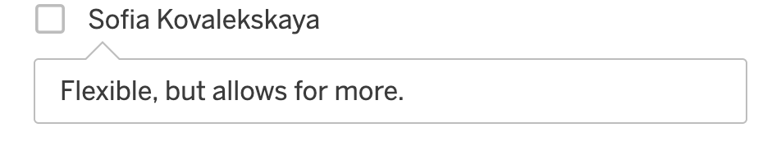
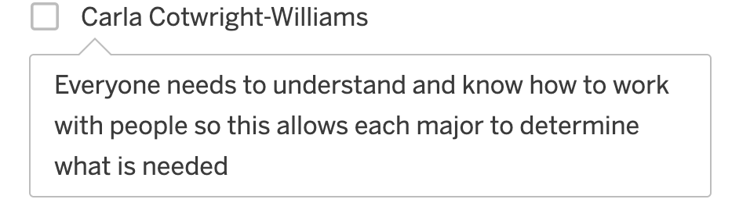
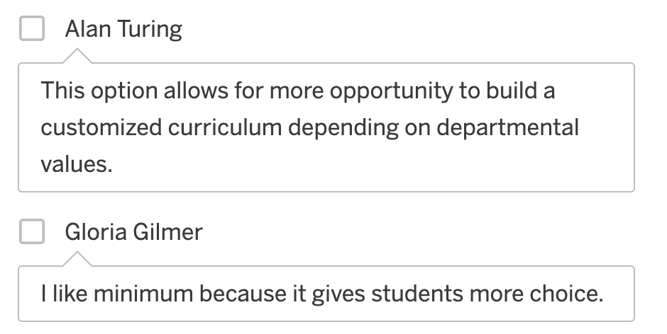

Communication
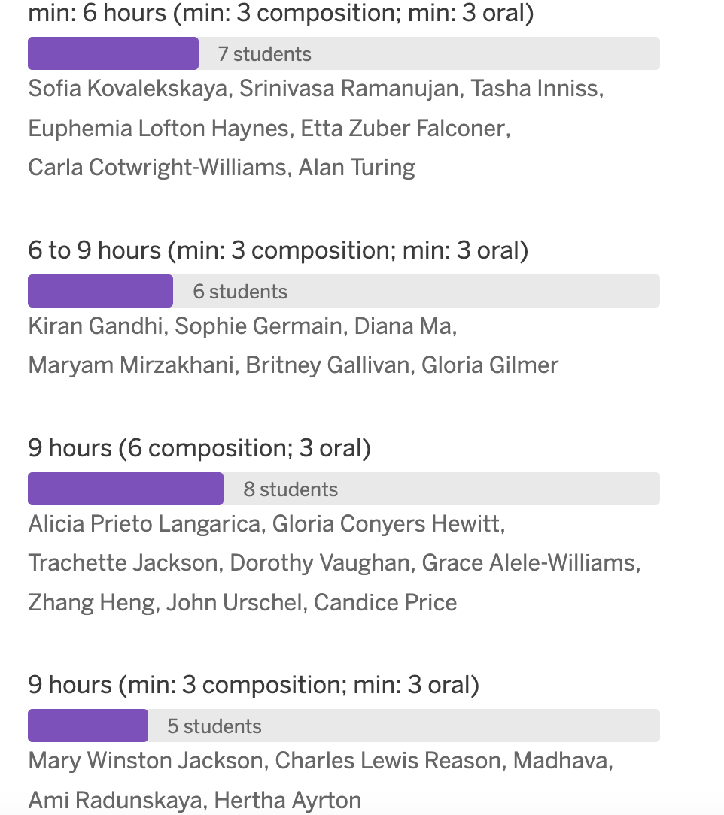

Comm Rationale

Min: 6 hours (min: 3 comps; min 3 oral)
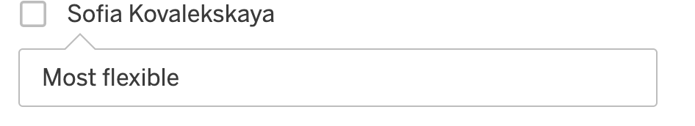
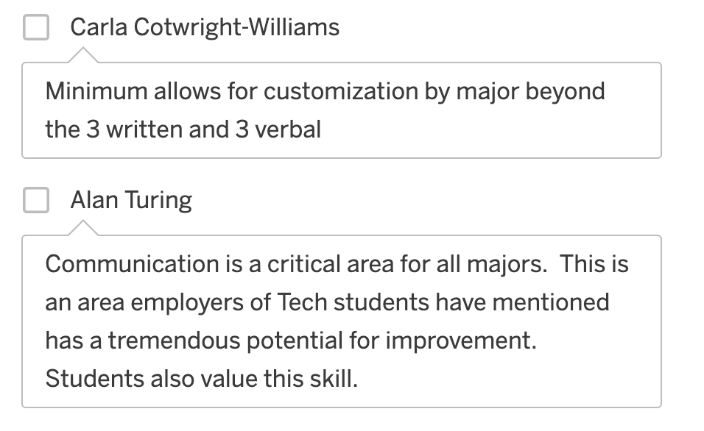

6 to 9 hours (min: 3 comps; min 3 oral)
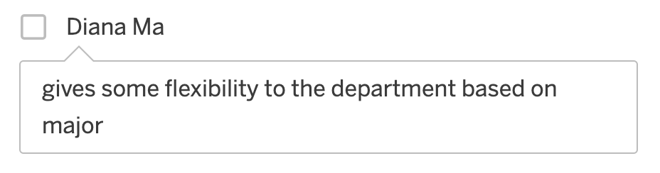
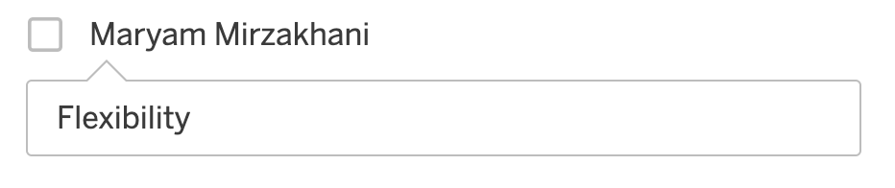

9 hours (6 comps; 3 oral)
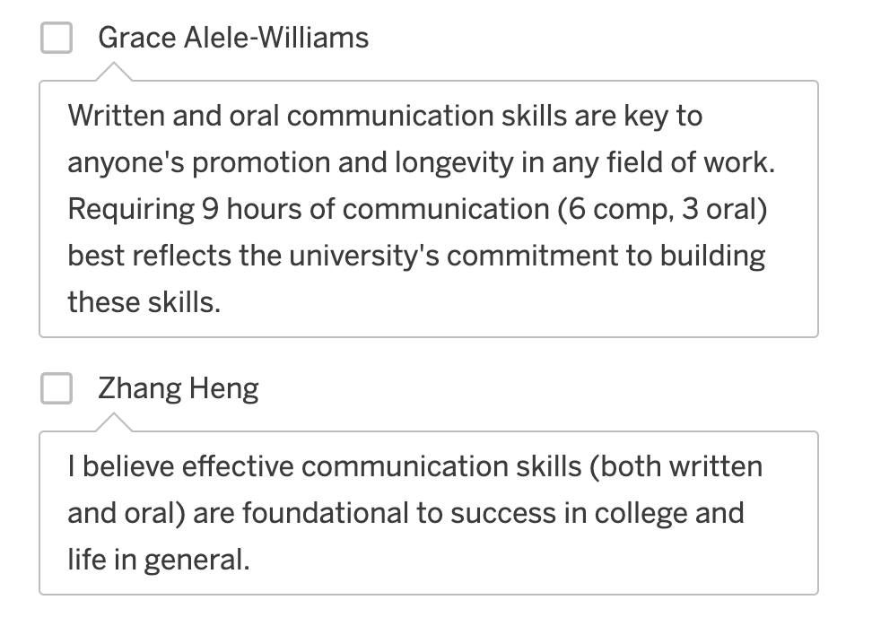

9 hours (min: 3 comps; min 3 oral)
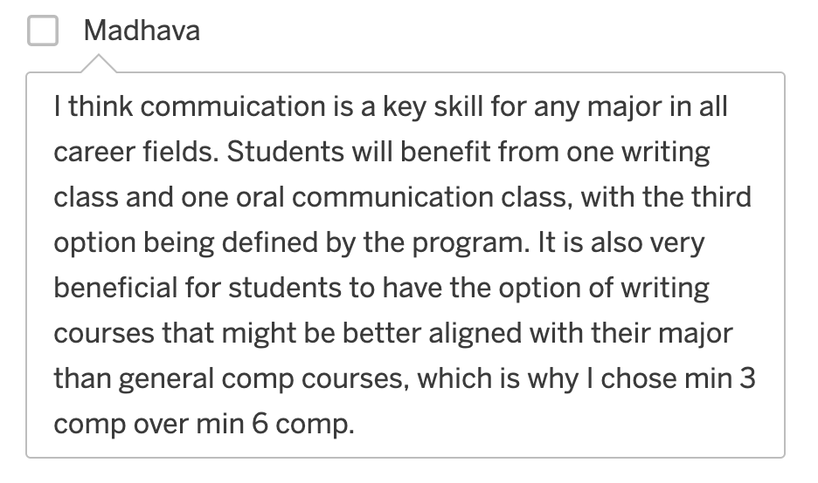
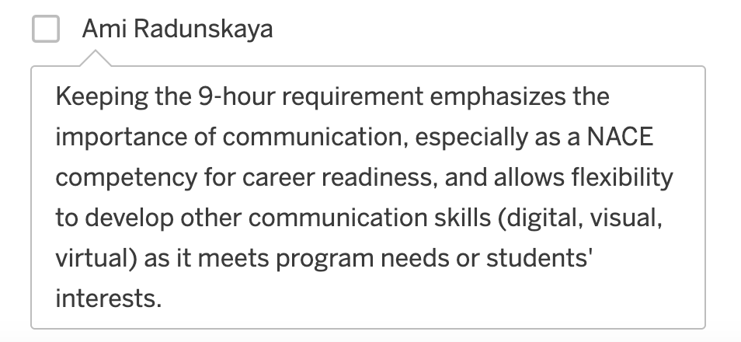

Scientific Reasoning
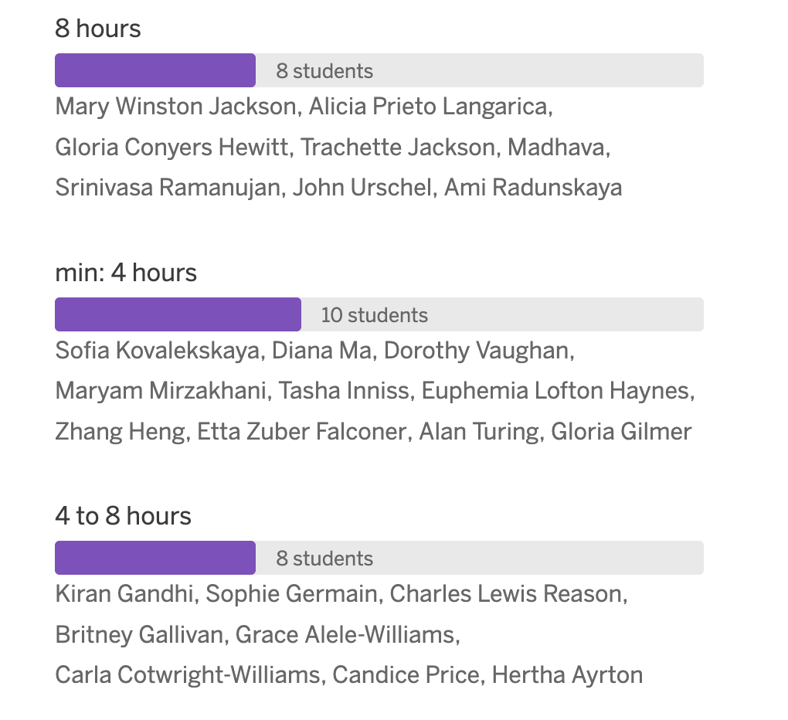

SR Rationale

8 hours
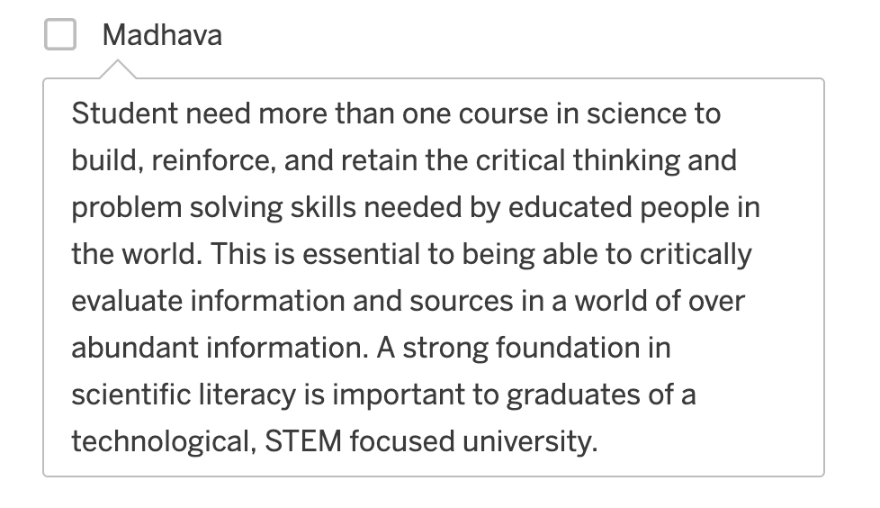
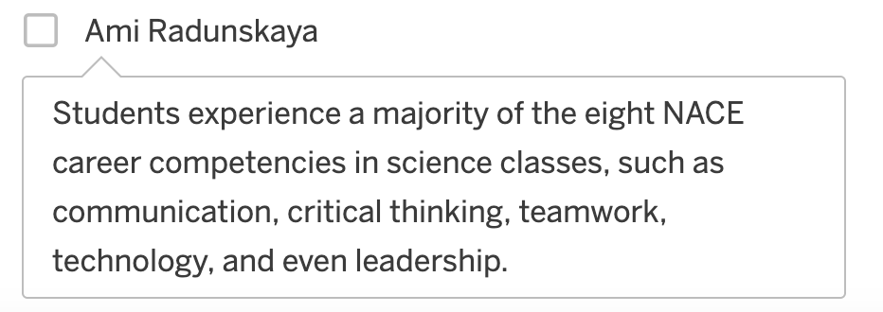

Min: 4 hours
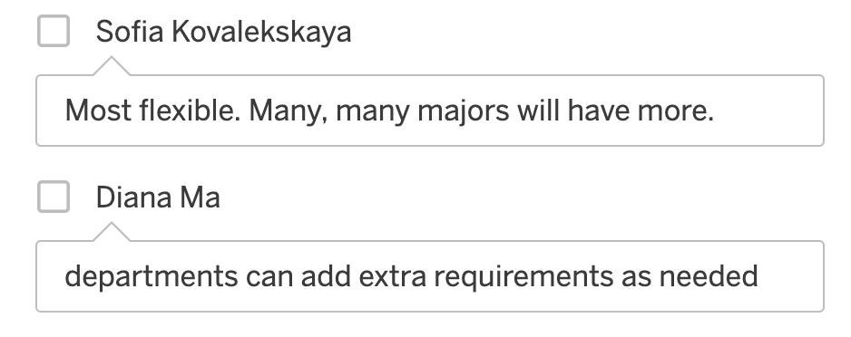
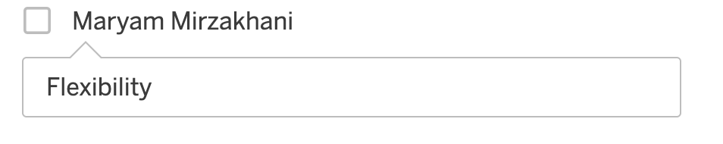
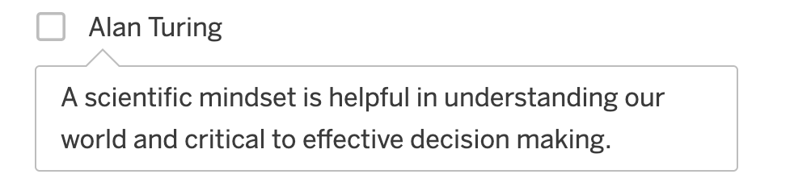

4 to 8 hours
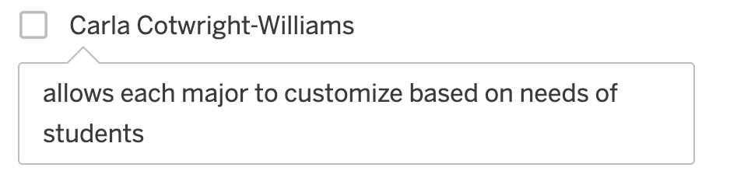

Financial & Digital Name Preference
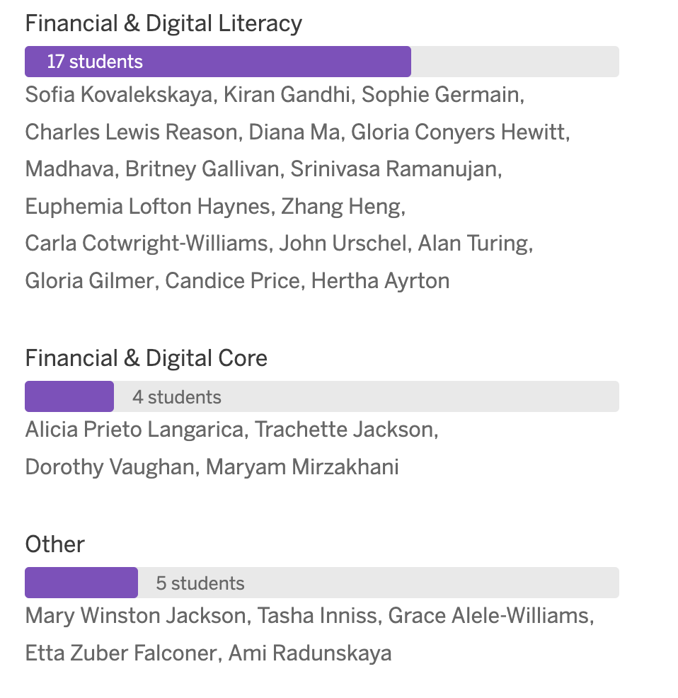

F&D Rationale

Financial & Digital Literacy
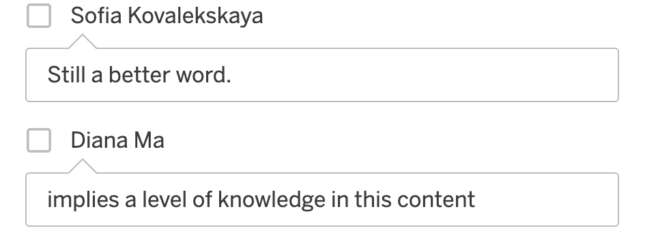
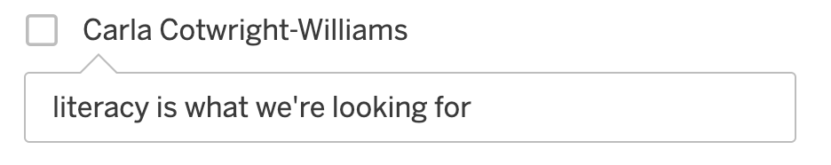

Financial & Digital Core
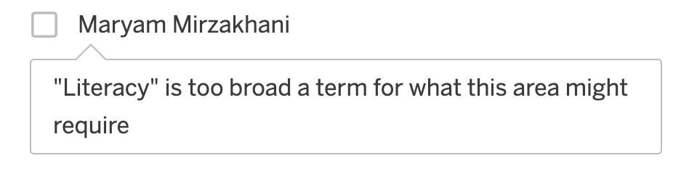

Other
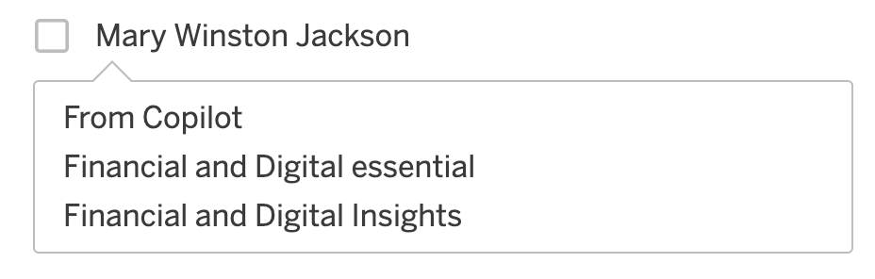
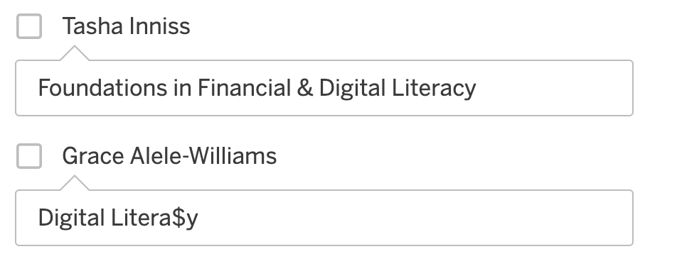
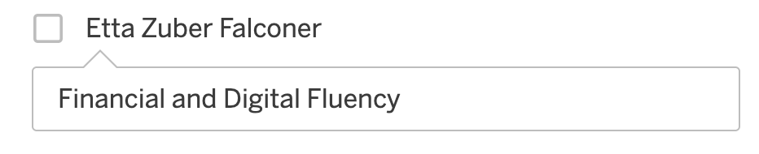
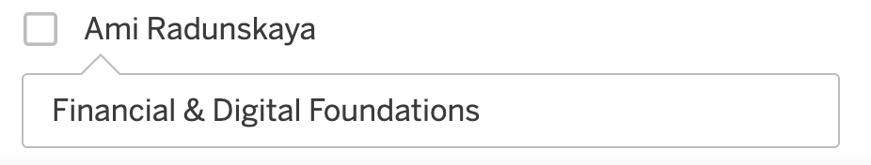

Financial & Digital Preference
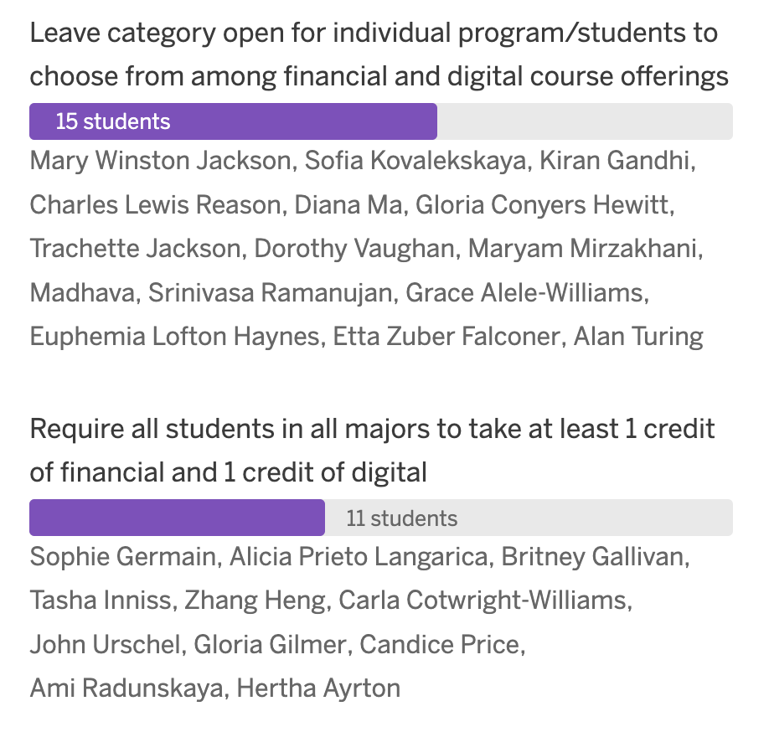

F&D Preference Rationale

Leave Category open for individual program/students to choose from among financial and digital course offerings.
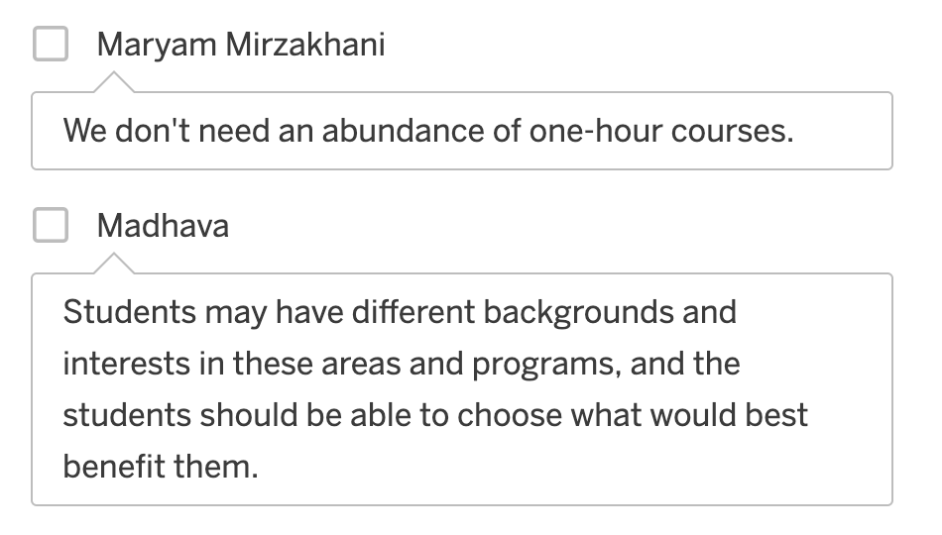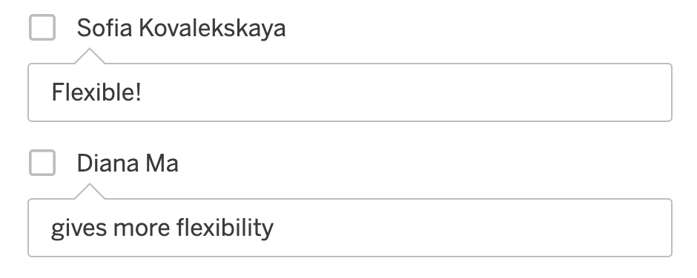

Require all students in all majors to take at least 1 credit of financial and 1 credit of digital
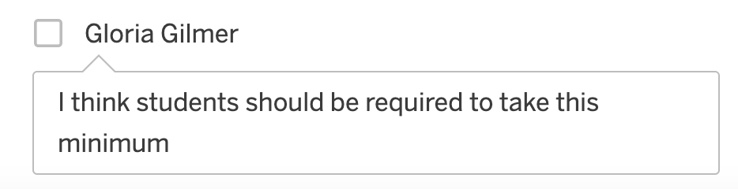

Financial & Digital Category
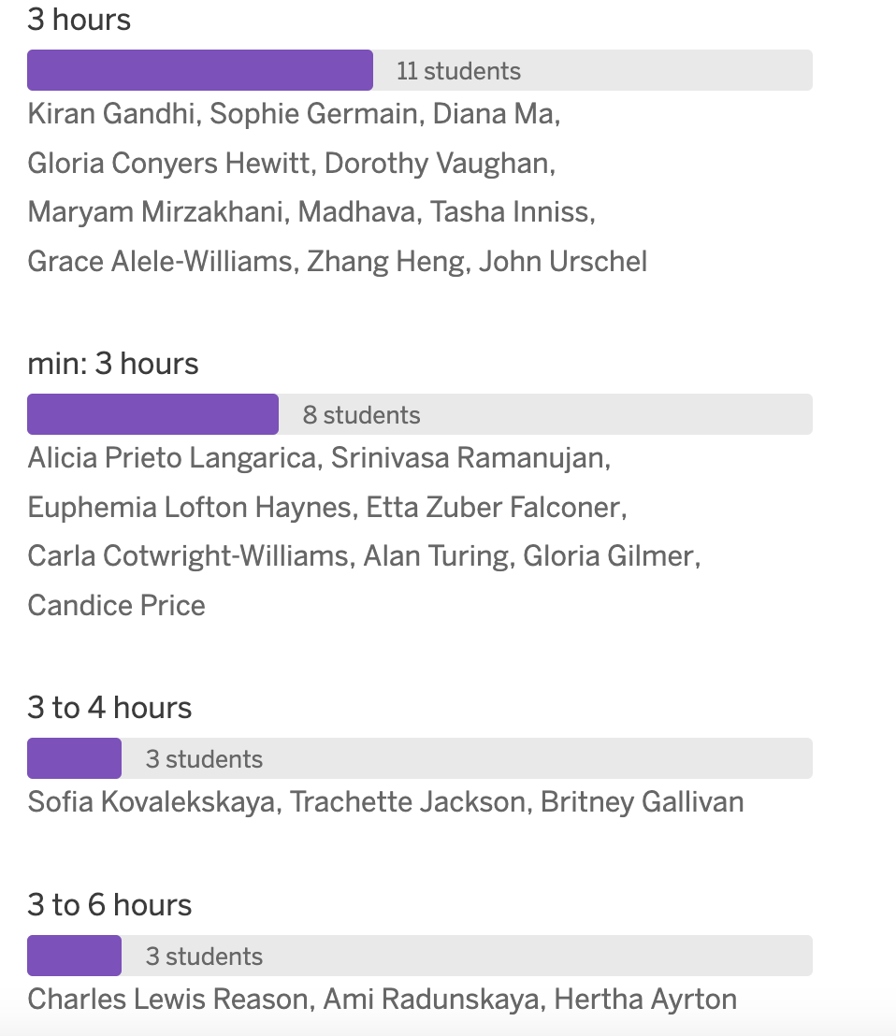

F&D Rationale

3 hours
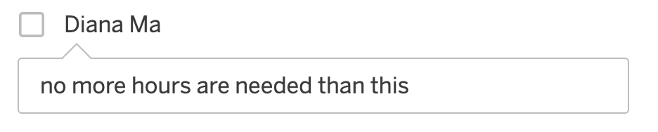
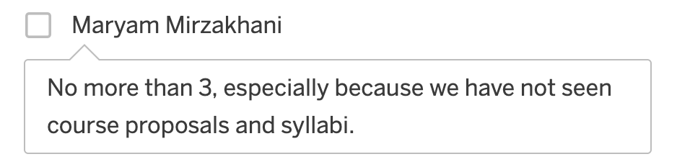

Min: 3 hours
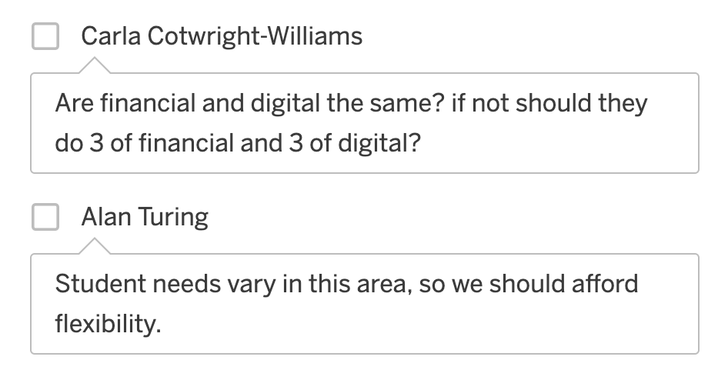

3 to 4 hours
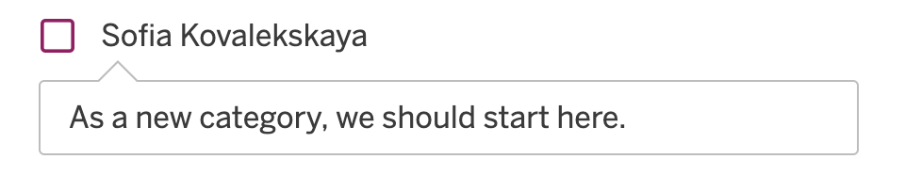

3 to 6 hours
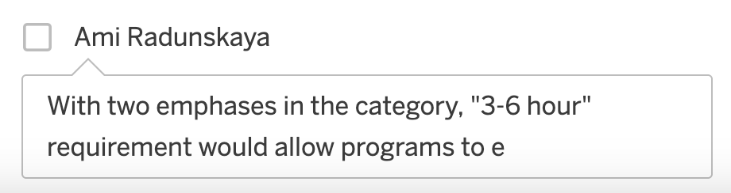

Voting
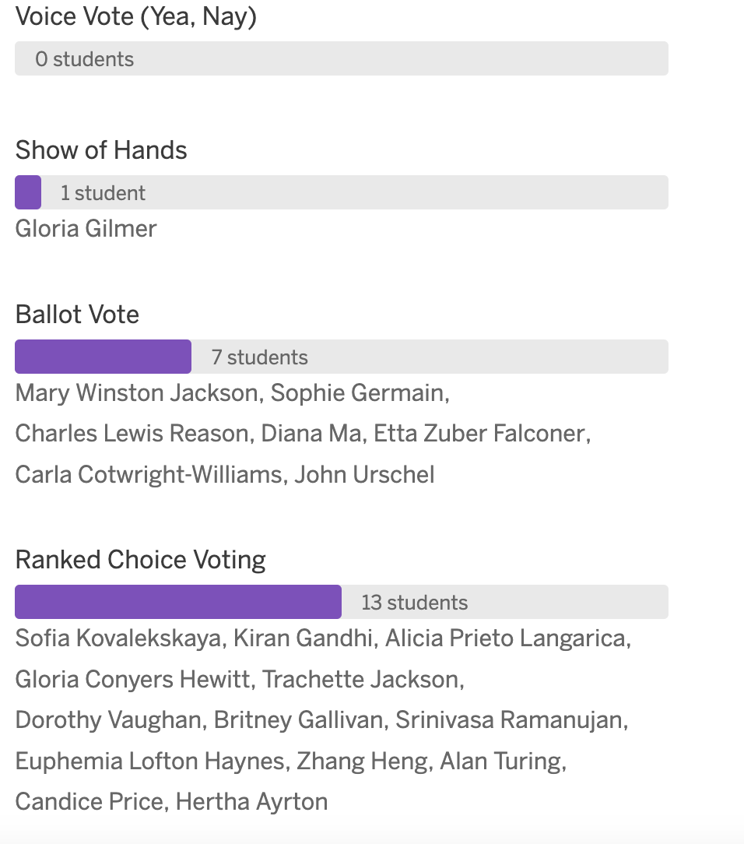
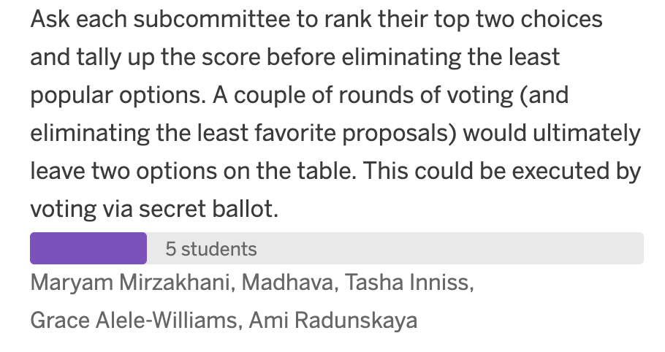

Voting Rationale

Voice Vote
No rationale given

Show of Hands
No rationale given

Ballot voting
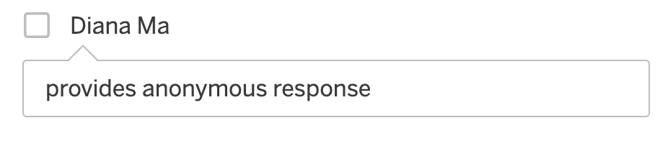

Ranked Choice Voting
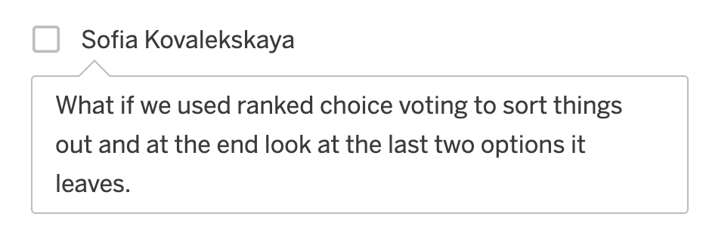

Each Subcommittee Rank their top Two Choices
No rational given

Proposals
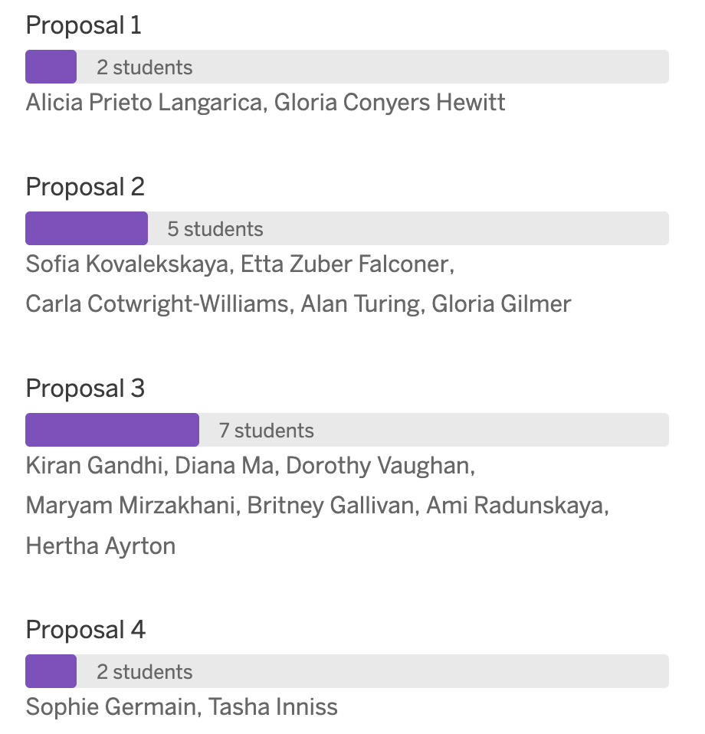
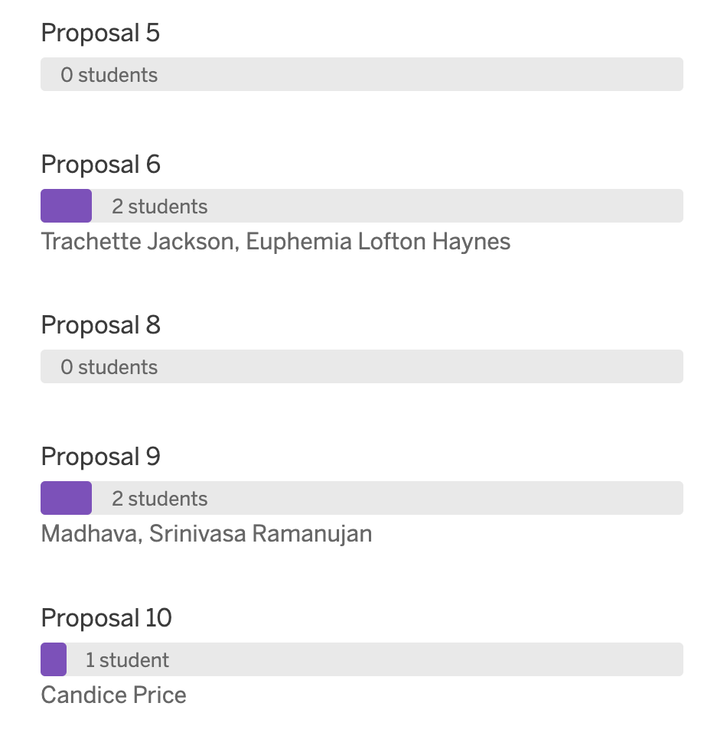
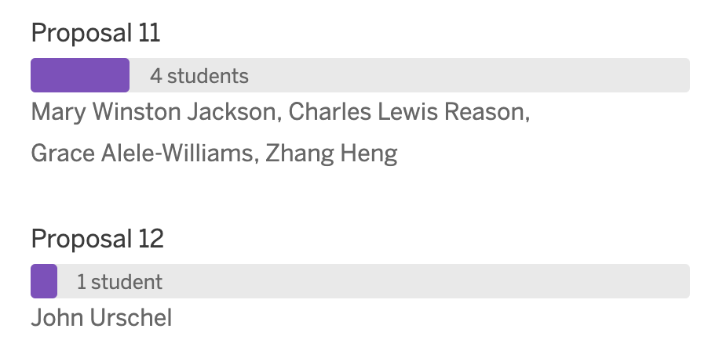

Proposals Rationale

Proposal 2
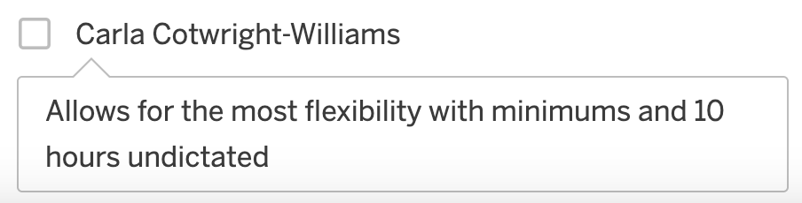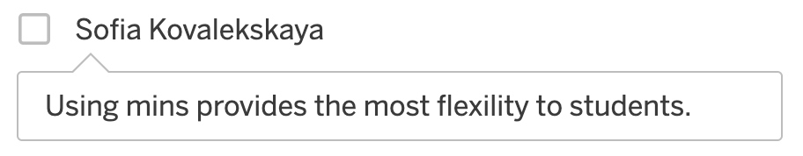

Proposal 3
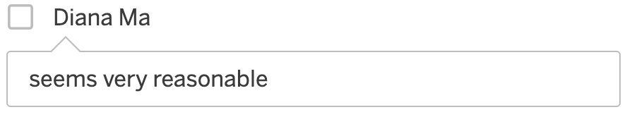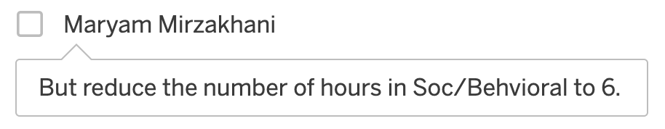

Proposal 9
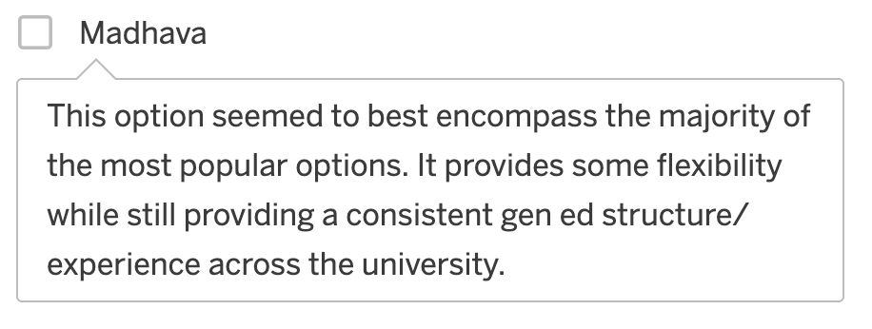

Proposal 11
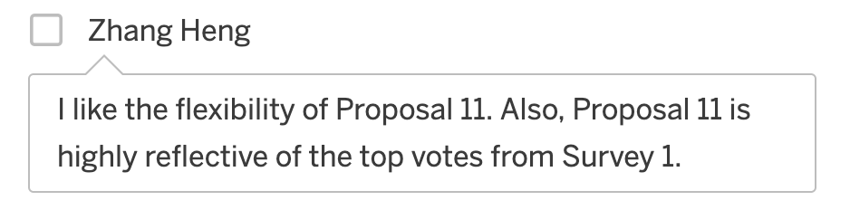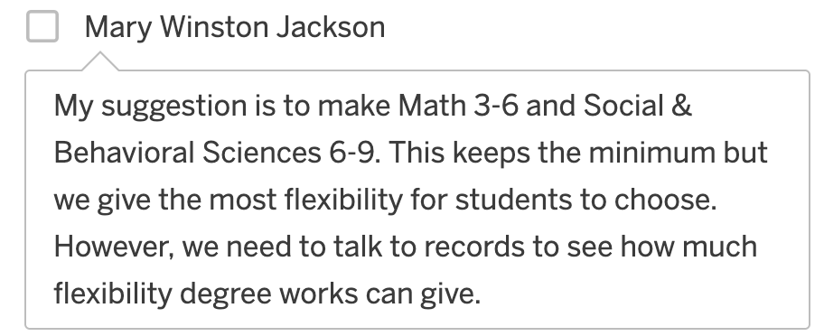

Final Thoughts
Do you have any ideas/comments to share with the group that you haven't already shared in a previous survey or previous slide?
