NOTE: Desmos, the survey system used in this survey, lists all respondents as “students” and anonymizes them by replacing their names with famous mathematicians. Respondents to this survey were exclusively members of the Gen Ed Implementation Committee.

Hours Choice 2
Should we put "max caps" on hours in categories? 2
Yes 2
No 4
Student Flexibility 6
Leave the language around flexible hours open (program faculty could remove some of the flexibility if they wish by specifying requirements within the "flexible hours" for their majors). 7
Specify that the flexible hours must be student choice. 8
Proposal Choice 9
Choose your top choice if we were to adopt one of the 3 proposals “as is.” 9
Between proposals 2 and 3, choose your top choice: 10
Between proposals 2 and 11, choose your top choice: 10
Between proposals 3 and 11, choose your top choice: 11
Final Thoughts 12

Hours Choice

Should we put "max caps" on hours in categories?
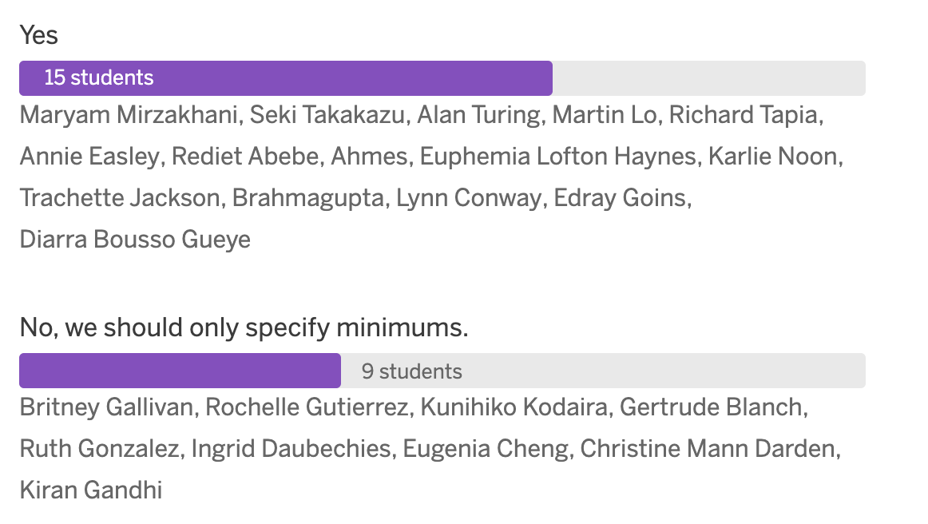

Yes
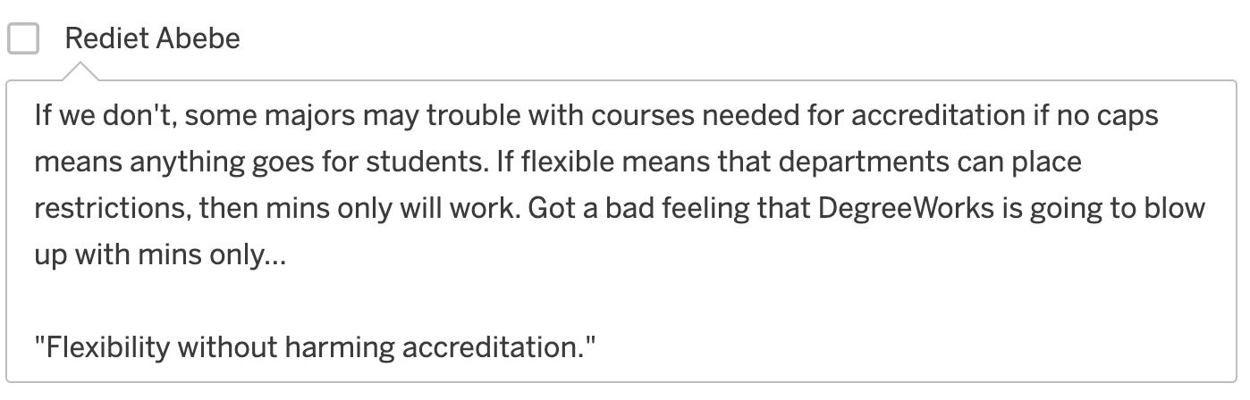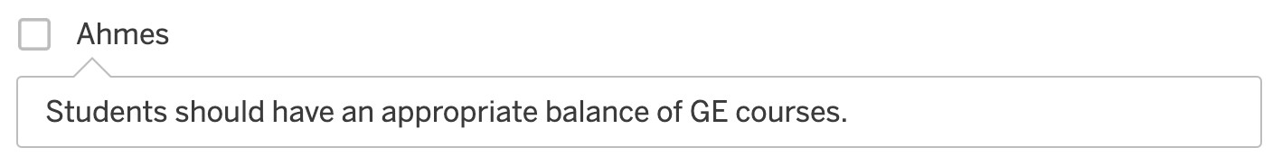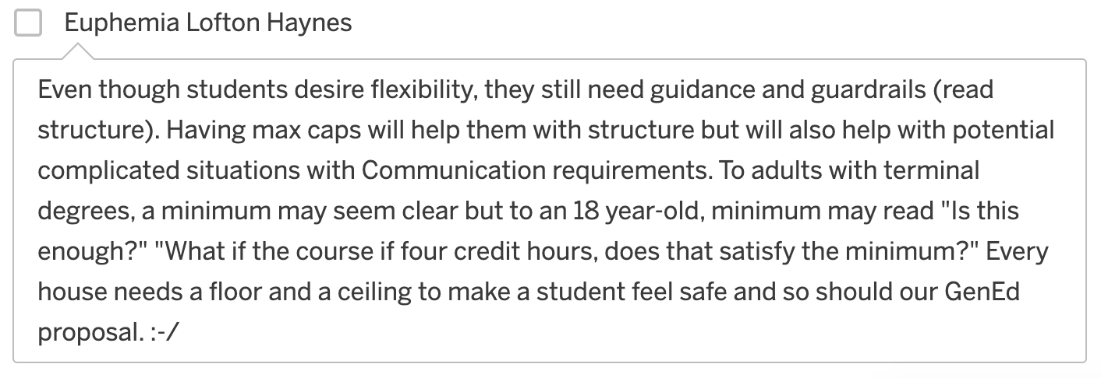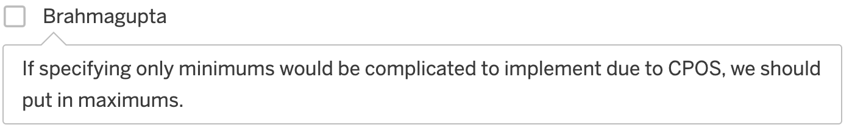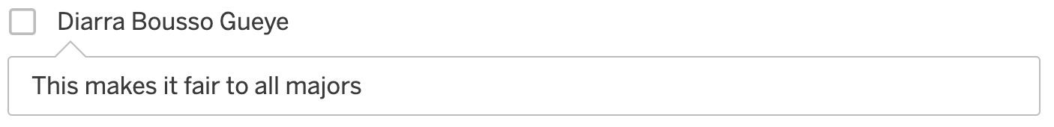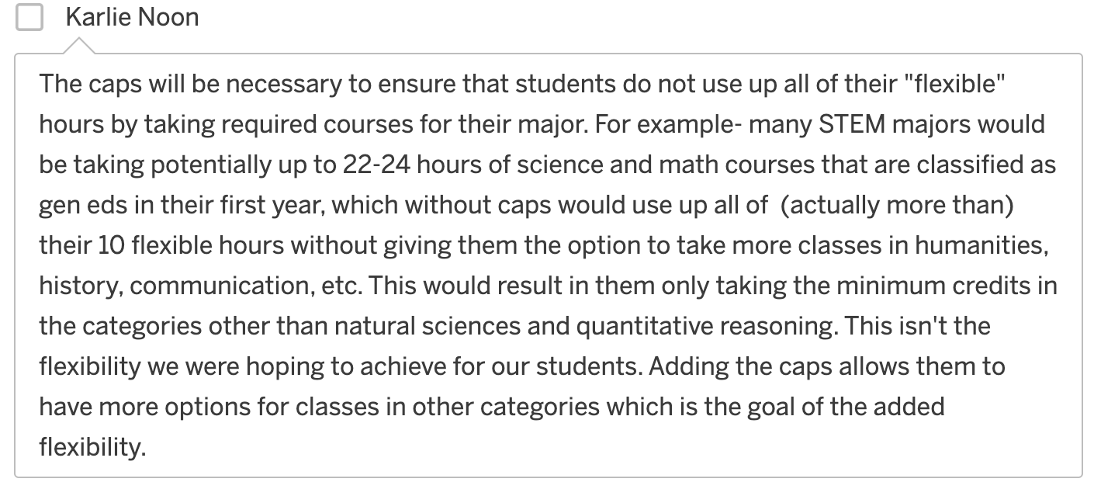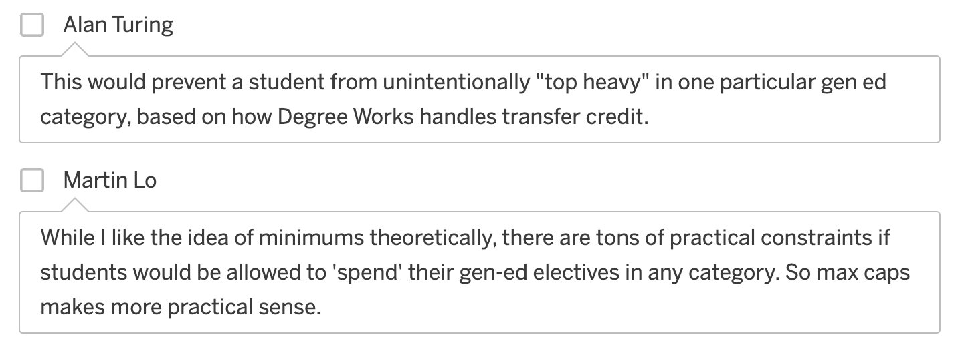
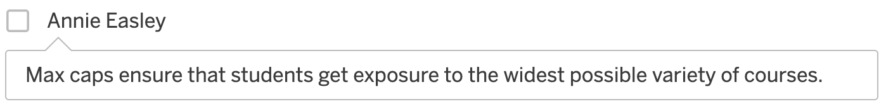

No
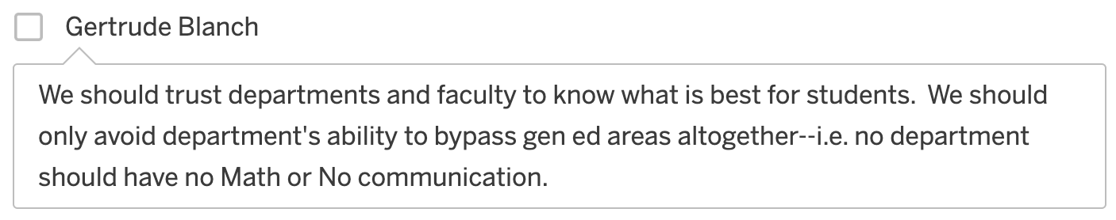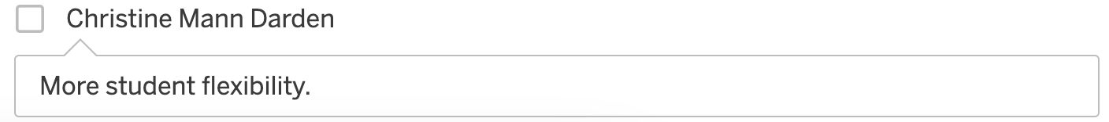
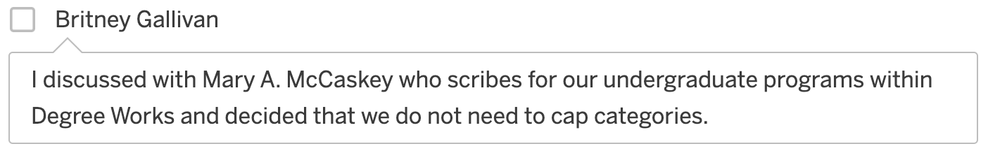

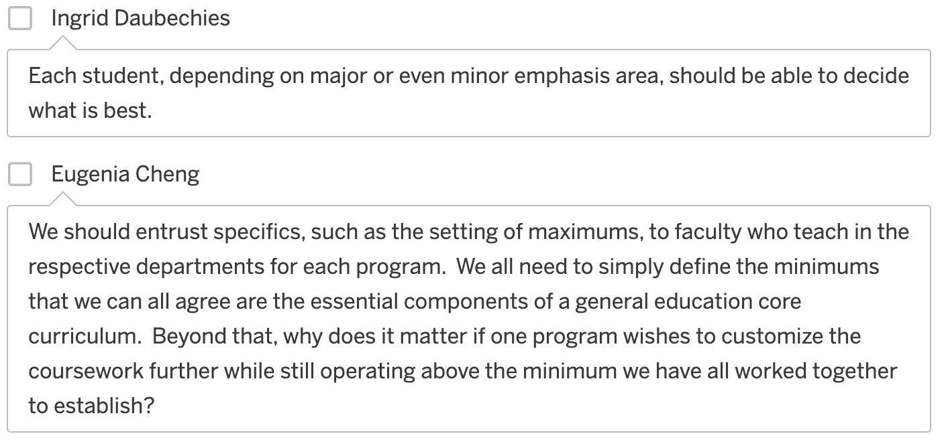

Student Flexibility
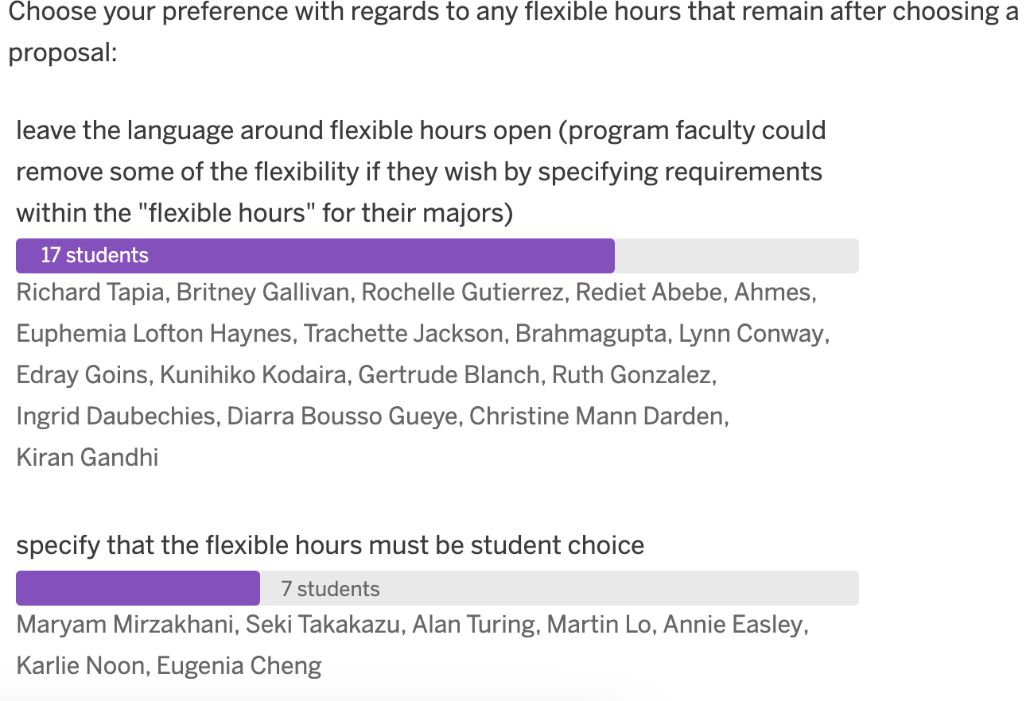

Leave the language around flexible hours open (program faculty could remove some of the flexibility if they wish by specifying requirements within the "flexible hours" for their majors).

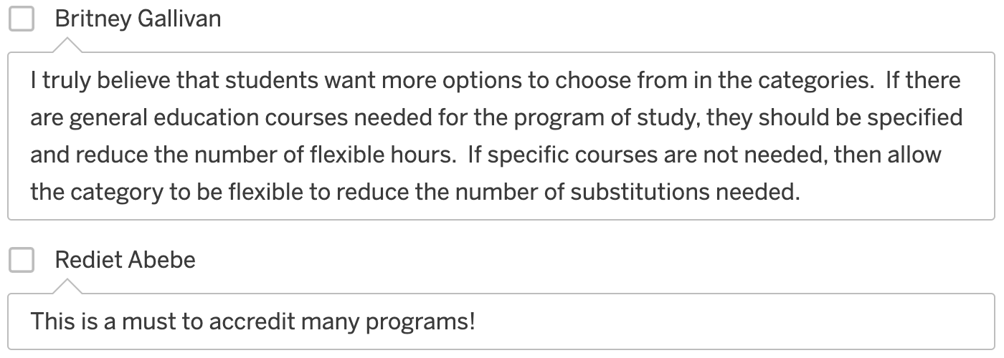

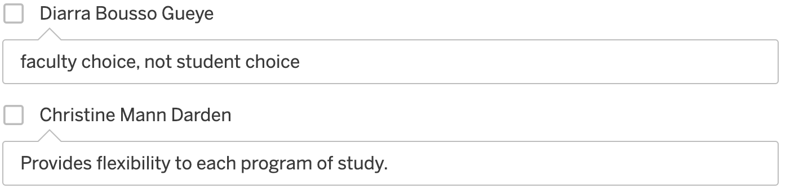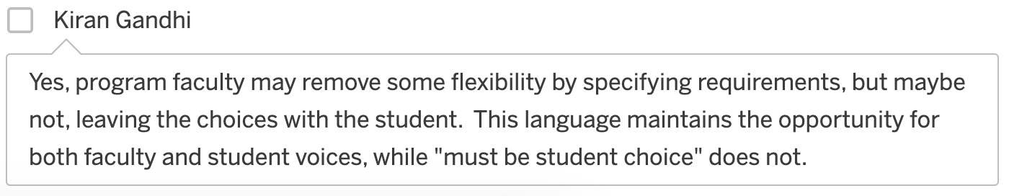
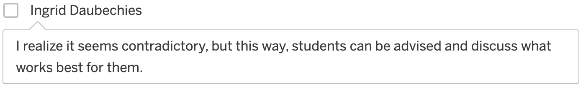

Specify that the flexible hours must be student choice.
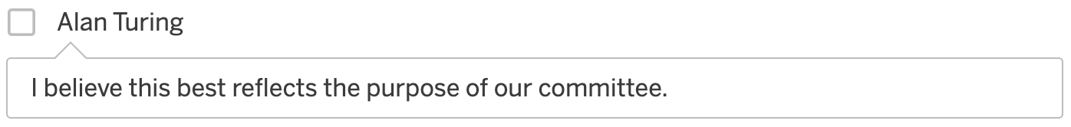
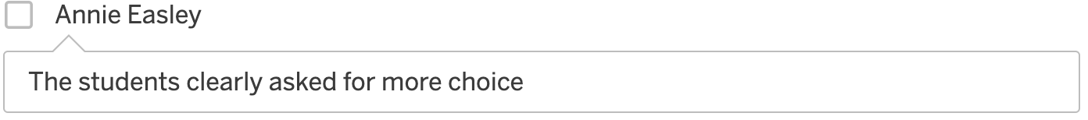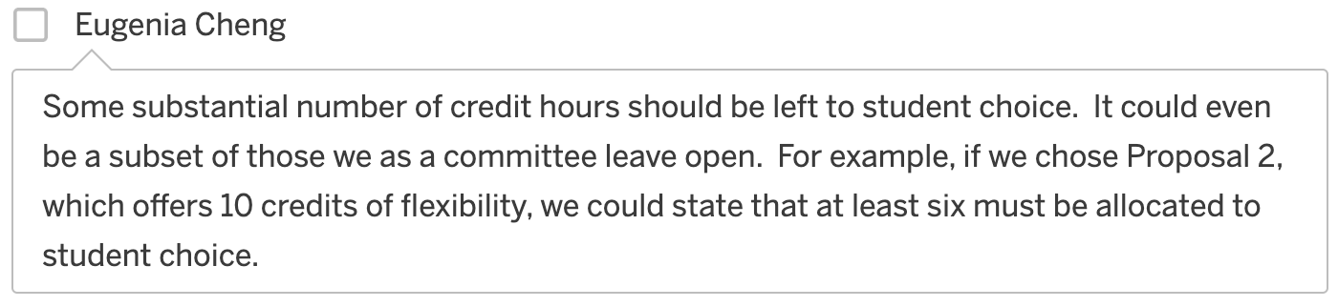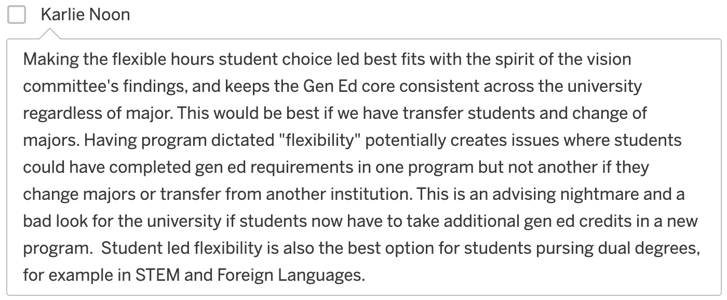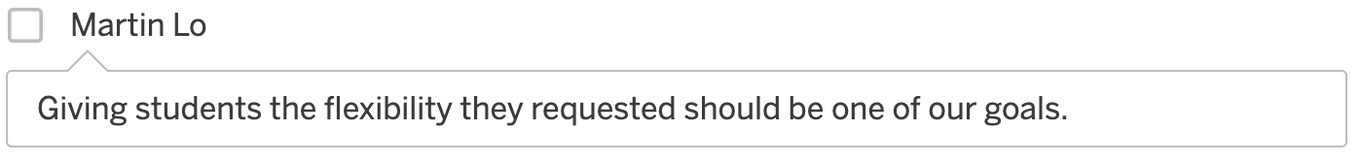

Proposal Choice

Choose your top choice if we were to adopt one of the 3 proposals “as is.”
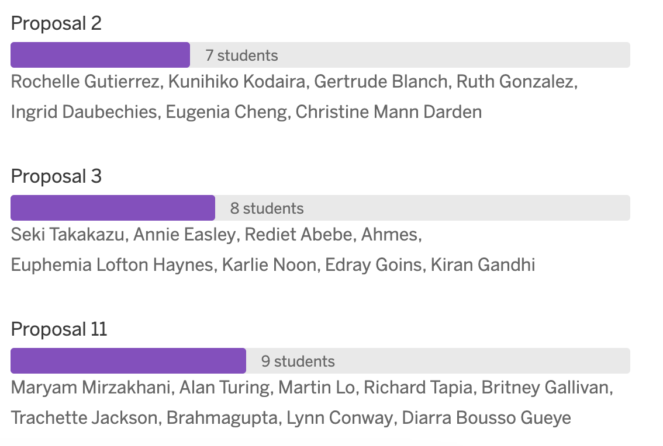

Between proposals 2 and 3, choose your top choice:

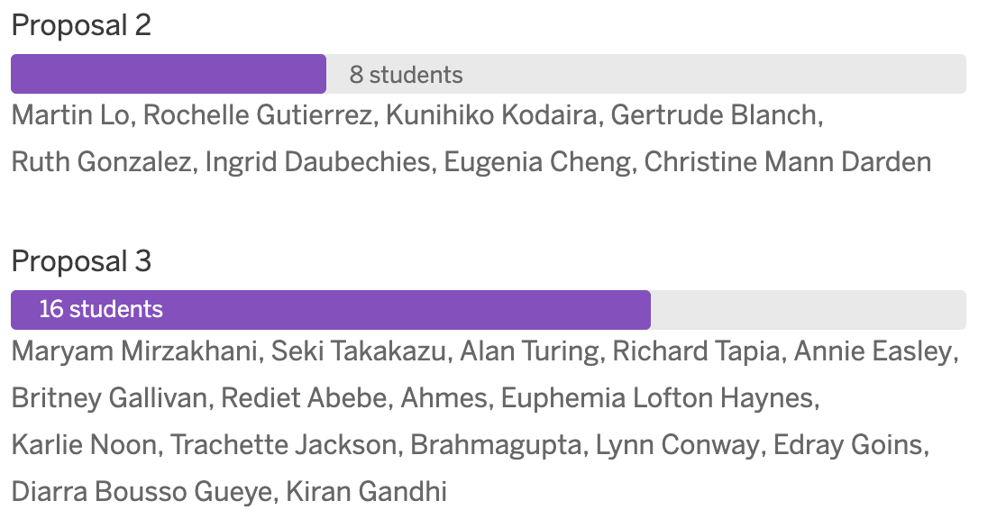

Between proposals 2 and 11, choose your top choice:

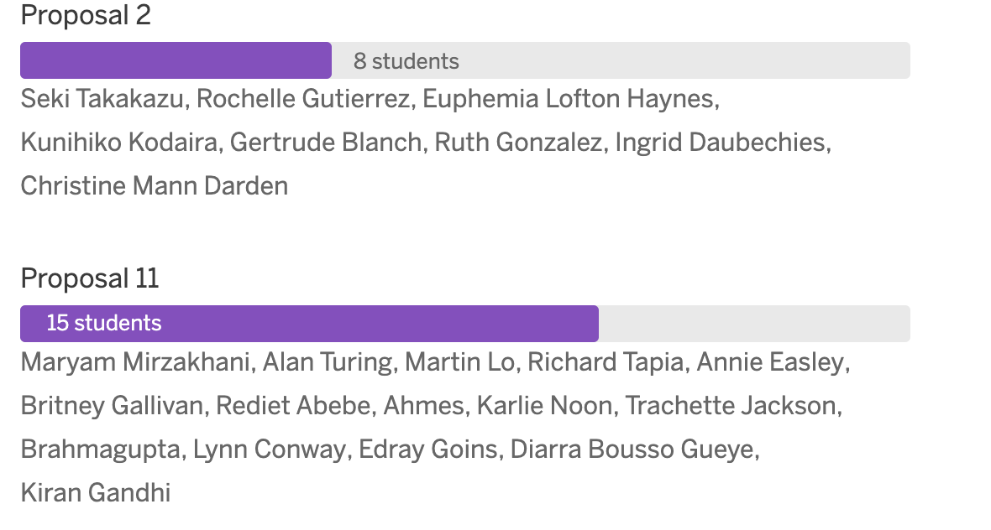

Between proposals 3 and 11, choose your top choice:
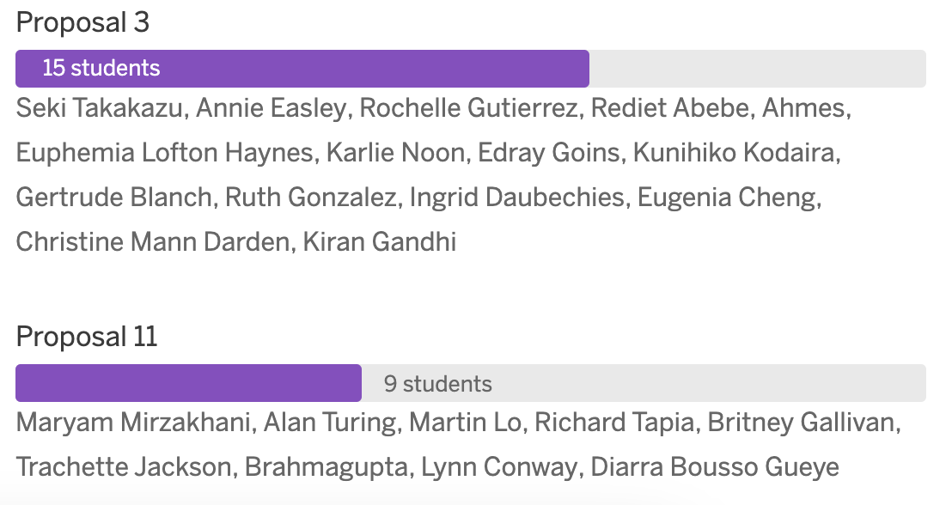

Final Thoughts

